School Name
Yearly Examination
2016
Year 10

Mathematics Course
General Instructions  - Reading time: 5 minutes  - Working time: 2 hours  - There will be a short break between Section 1 and Section 2  - Write using black or blue pen  - You may use a pencil to draw or complete diagrams  - Attempt ALL questions  - Approved calculators may be used in Section 2.  - Write your Name and Teacher’s Name in the spaces provided.  - A formula Sheet is on the reverse of this page and can be detached and used in all sections of the test. | Total Marks – 100  Section 1  Non Calculator Section.  25 marks  Time allowed for this section is 30 minutes.  Write all answers in the spaces provided.  Section 2  Time allowed for this section is 1 hour and 30 minutes.  Part A  Multiple Choice Section.  Mark your answers on the separate answer sheet at the end of the examination.  50 marks  Part B  Longer Answer Section.  Write all answers in the spaces provided.  25 marks

Formula Sheet
Pythagoras’ Theorem
c = hypotenuse
a and b are the shorter sides

Circumference of a circle
d = diameter

Area of a circle
r = radius

Area of a parallelogram
b = base
h = perpendicular height

Area of a rhombus or kite
x and y are the diagonals

Area of a trapezium
h = perpendicular height
a and b are the parallel sides

Volume of a prism
A = area of base
h = perpendicular height

Volume of a pyramid
A = area of base
h = perpendicular height

Volume of a cylinder
r = radius
h = perpendicular height

Volume of a cone

Volume of a sphere
Surface Area of a Cylinder

Surface Area of Cone
r = radius
l = slant height

Surface Area of a sphere

Trigonometric formulae for a triangle ABC.

Sine Rule

Cosine Rule
or
Area of a triangle
Simple interest
P = Principal
R = interest rate per time period as a decimal
T = number of time periods

Compound Interest
A = Final amount to which the investment grows
P = Principal
r = interest rate per compounding period as a decimal
n = number of compounding periods
Depreciation
SV = Salvage Value to which the initial value falls
IV = Initial Value
r = depreciation rate per compounding period as a decimal
n = number of compounding periods

Gradient of a line
and are points on the line
m = gradient

Midpoint of a line segment

Length of a line segment
Equation of a line
or
b = y intercept

School Name
Yearly Examination
Mathematics Course
2016

Class/Teacher ______________________

Name______________________

Section 1

25 marks
Time allowed for this section is 30 minutes

Answer Questions 1–25 in the spaces provided.

Calculators are NOT to be used in this section.

There will be a short break between Section 1 and Section 2.

Section 1 Non Calculator Section
 | Write all working and answers in the spaces provided on this test paper.
1. | A bus has 35 passengers of whom 28 are children and the rest are adults.  What percentage of the passengers are children?  ……………………………………………………………………………………………....  ……………………………………………………………………………………………….
2. | 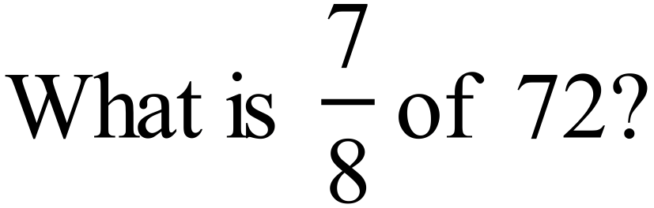  ……………………………………………………………………………………………....  ……………………………………………………………………………………………….
3. | 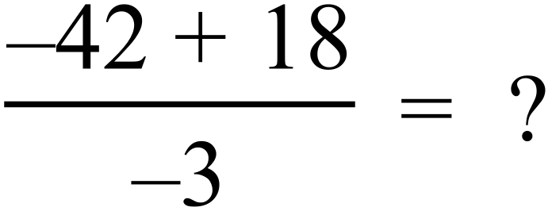  ……………………………………………………………………………………………....  ……………………………………………………………………………………………….
4. | 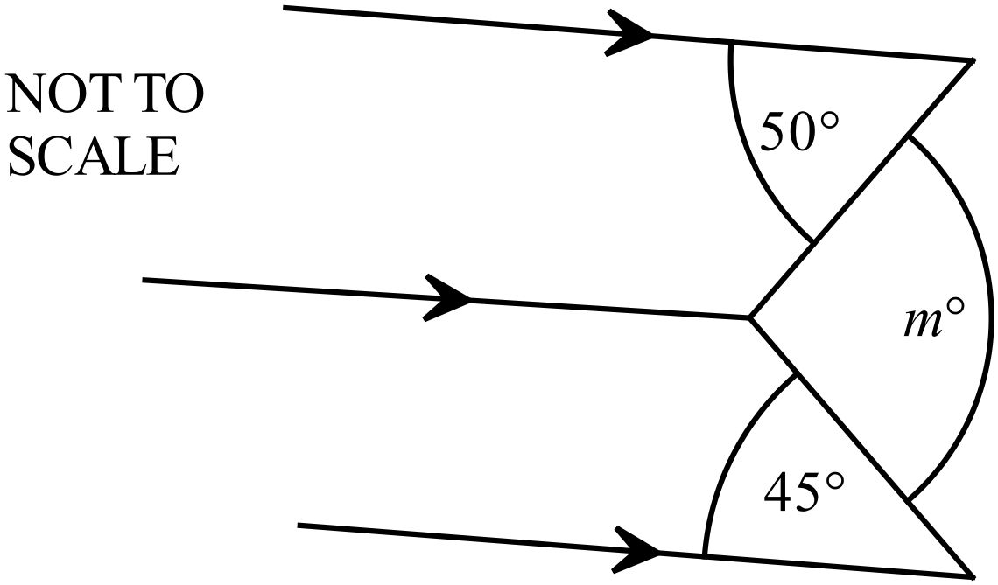Find the value of m in this diagram.  ……..…………………………………………  ……………………………………………….  ………………………………………………  ………………………………………….……
5. | What is the value of x in the quadrilateral below?  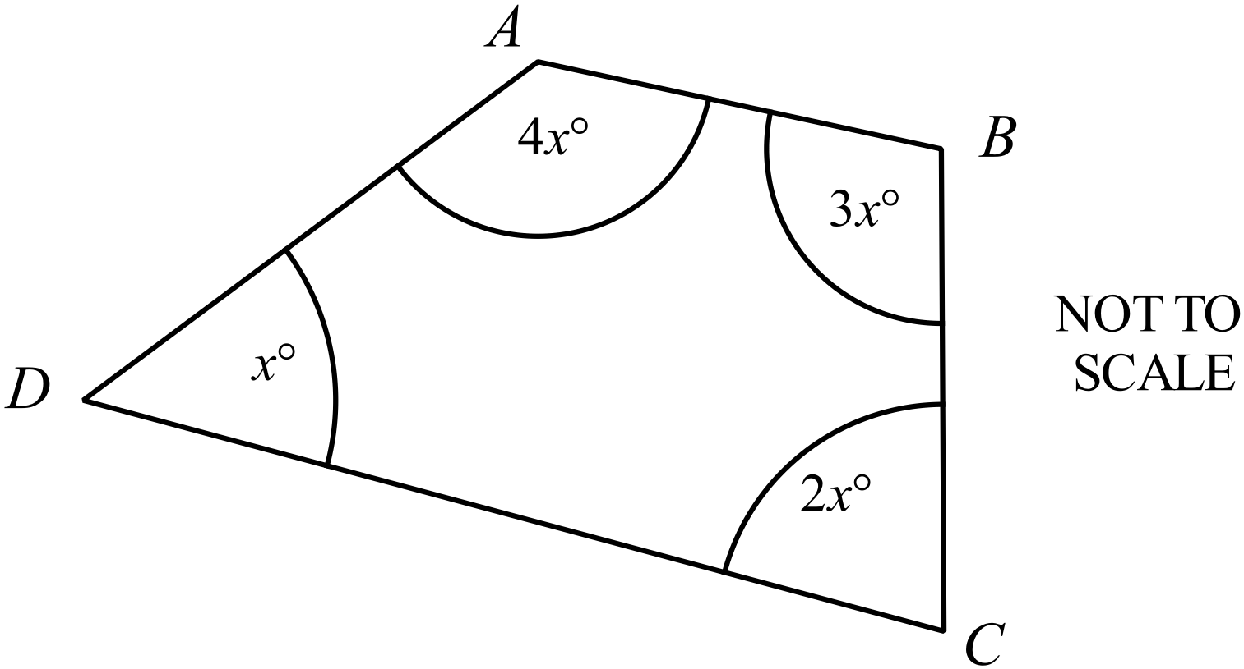  ……..…………………………………………  ……………………………………………….  ………………………………………………  ………………………………………….……
6. | 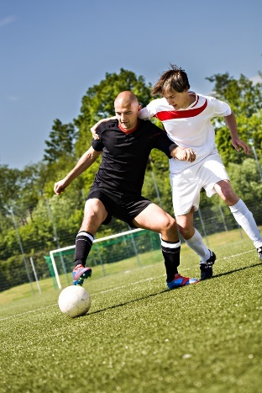  In November, Glasgow time is 9 hours behind Sydney time.  A soccer match is to be played in Glasgow, starting at 1:45 pm on Saturday 12th November.  At what local time in Sydney would the game begin?  ………………………………………………………………………….  ………………………………………………………………………….  …………………………………………………………………………
7. | 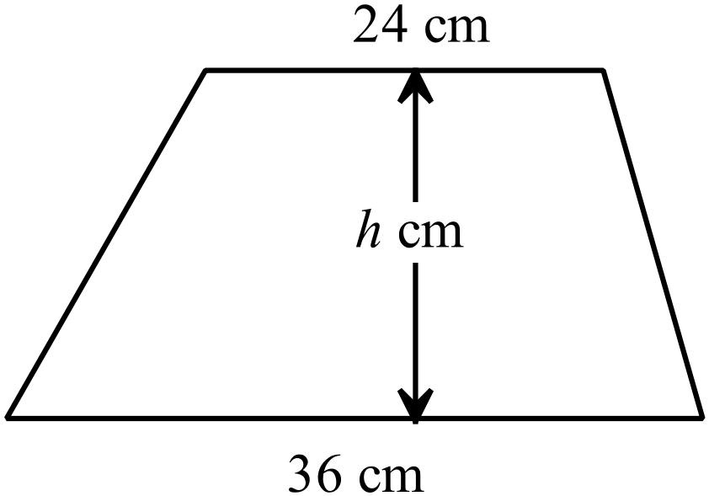The trapezium shown has an area of 540 cm².  What is the value of h?  .……………………………………………………  …………………………………………………....  ……………………………………………………
8. | Blake plans to lay a slab of concrete in the shape shown.  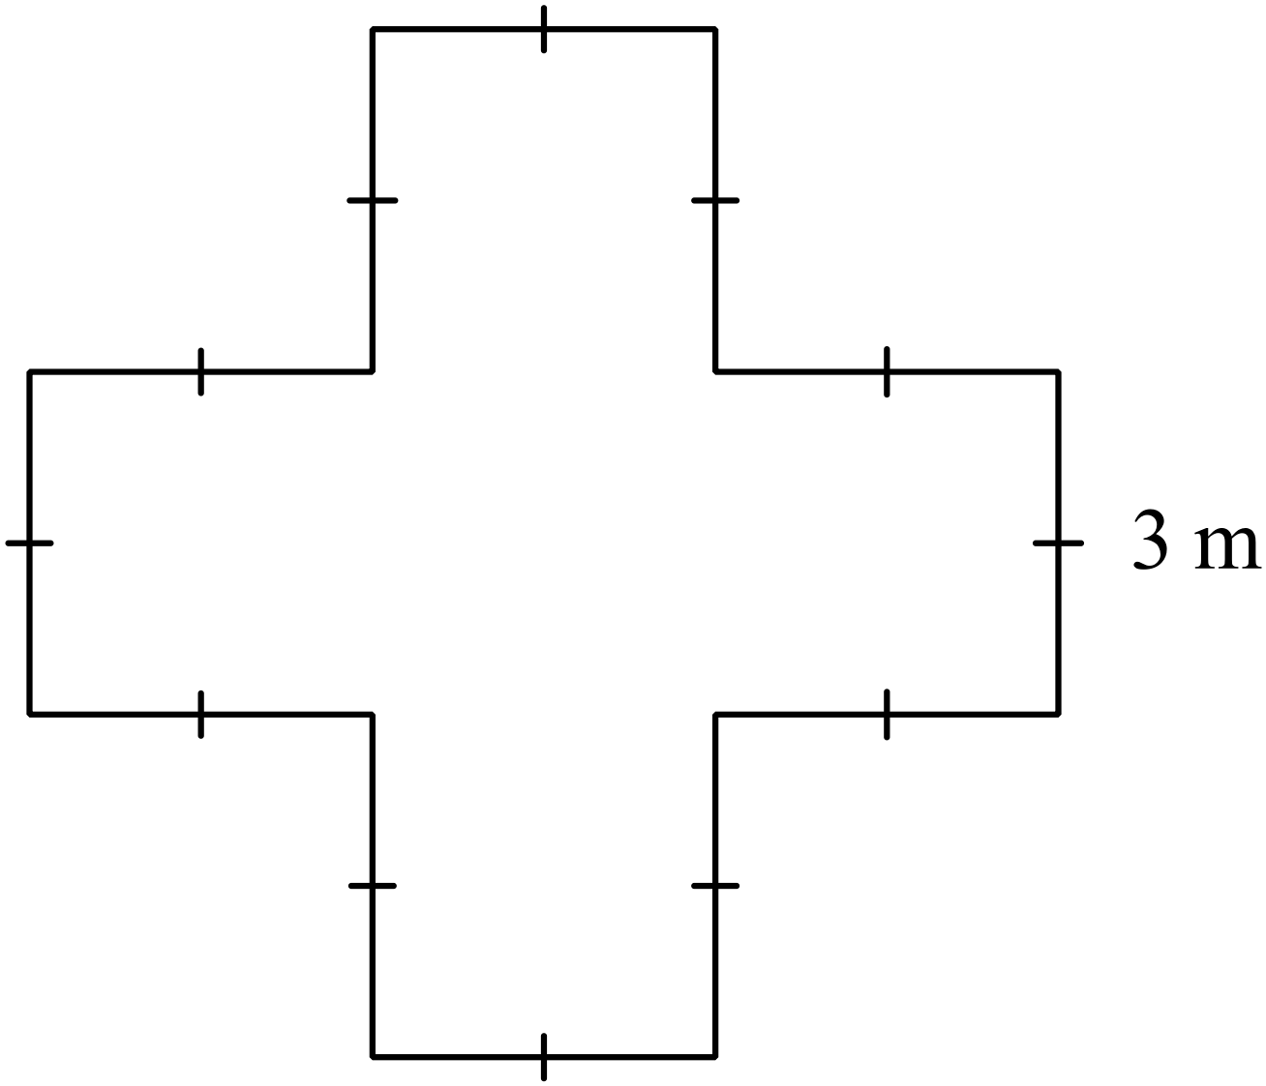All angles are right angles and each side measures 3 metres.  The slab is to have a uniform thickness of 20 cm.  How many cubic metres of concrete is needed for the slab?  ……………………………………………………  ………...………………………………………....  ………...………………………………………....  ……………………………………………………
9. | Use the formula 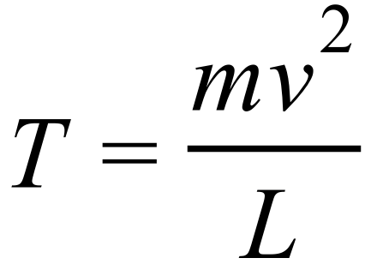 to find the value of T when  ……………………………………………………………………………………………....  ……………………………………………………………………………………………….
10. | Expand and simplify 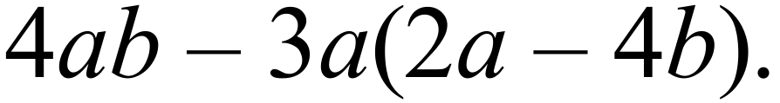  ……………………………………………………………………………………………....  ……………………………………………………………………………………………….
11. | 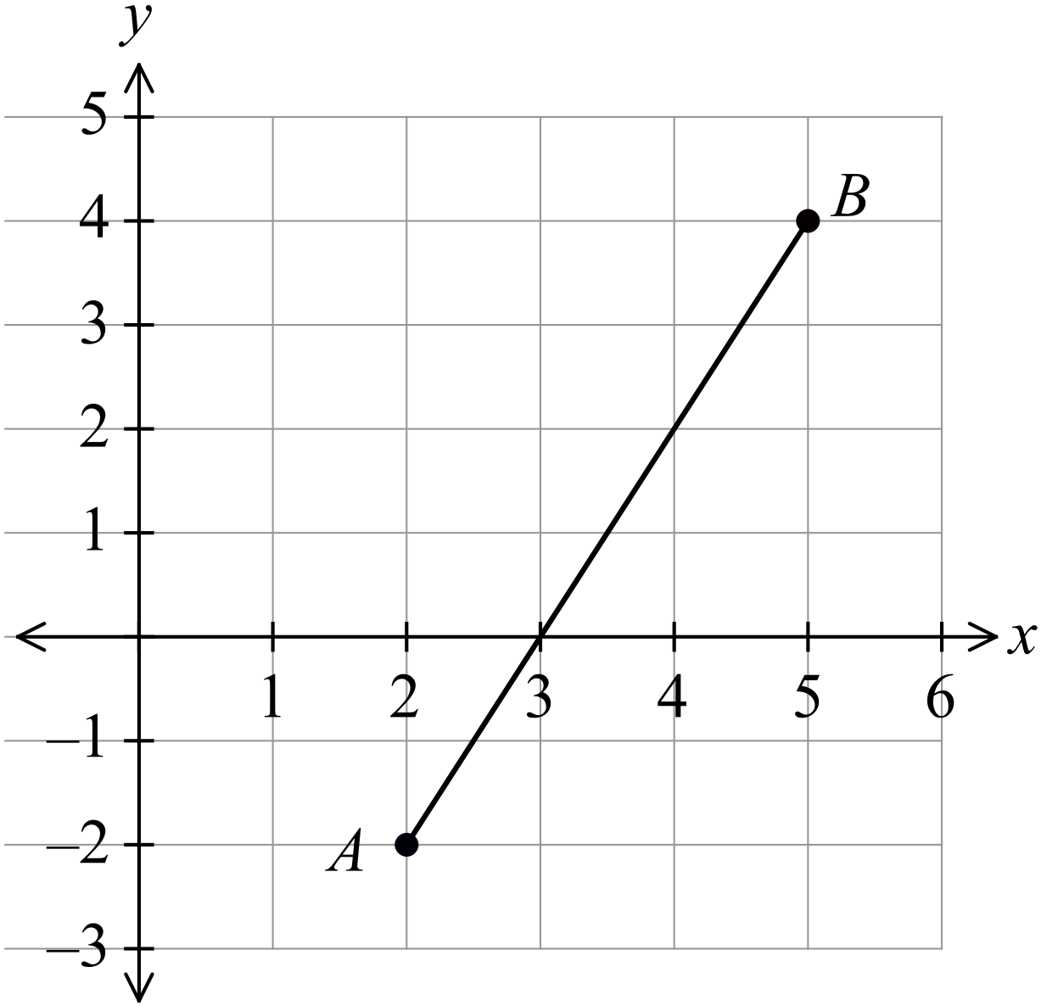What is the gradient of the interval AB on the number plane shown?  ……………………………………………  …………………………………………....  ……………………………………………  …………………………………………….
12. | Simplify 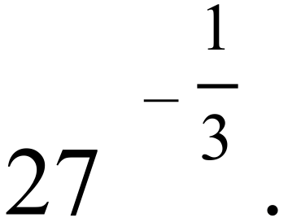  ……………………………………………………………………………………………....  ……………………………………………………………………………………………….
13. | Find the value of d for which 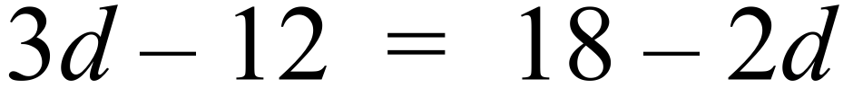.  ……………………………………………………………………………………………....  ……………………………………………………………………………………………....  ……………………………………………………………………………………………….
Questions 14 and 15 refer to the following:
Six girls contributed photographs for a school magazine.
The graph shows their contributions.

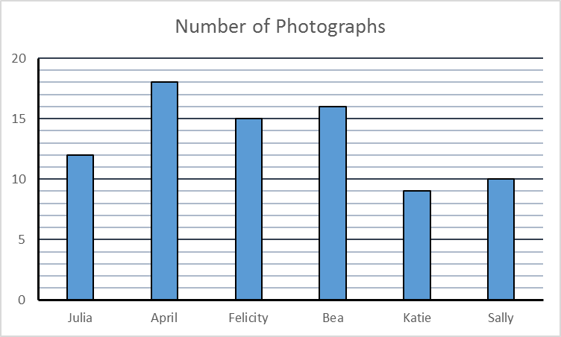
NAME
NUMBER OF PHOTOGRAPHS

14. | What percentage of the photographs did Bea contribute?  ……………………………………………………………………………………………....  ……………………………………………………………………………………………….
15. | What was the mean number of photographs contributed by the girls?  Answer as a fraction in simplest form.  ……………………………………………………………………………………………....  ……………………………………………………………………………………………….
16. | Jason took part in two fun runs.  He took 2 hours and 20 minutes for the first run and 1 hour and 45 minutes for the second run.  What is the ratio of his times to complete the two runs?  ……………………………………………………………………………………………....  ……………………………………………………………………………………………….
17. | What is the midpoint of the interval joining P (-6, 10) and Q (4, 5) ?  ……………………………………………………………………………………………....  ……………………………………………………………………………………………….
18. | What is the value of 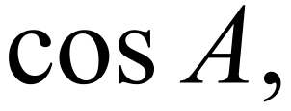 in the triangle ABC?  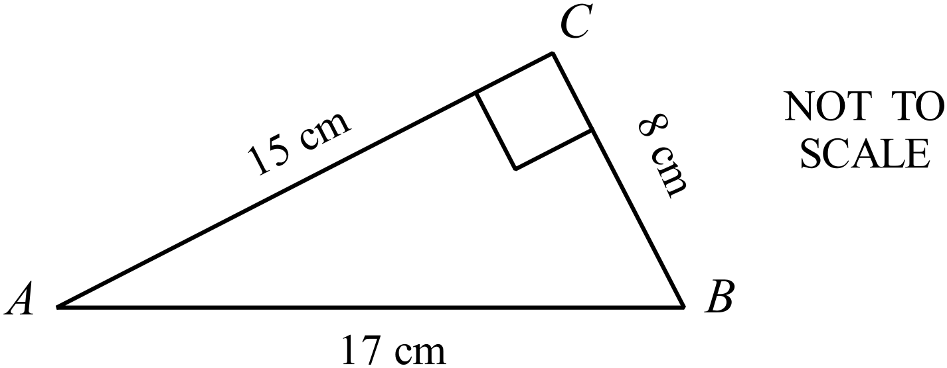 ……………………………………………………  ………...………………………………………....  ………...………………………………………....  ……………………………………………………
19. | 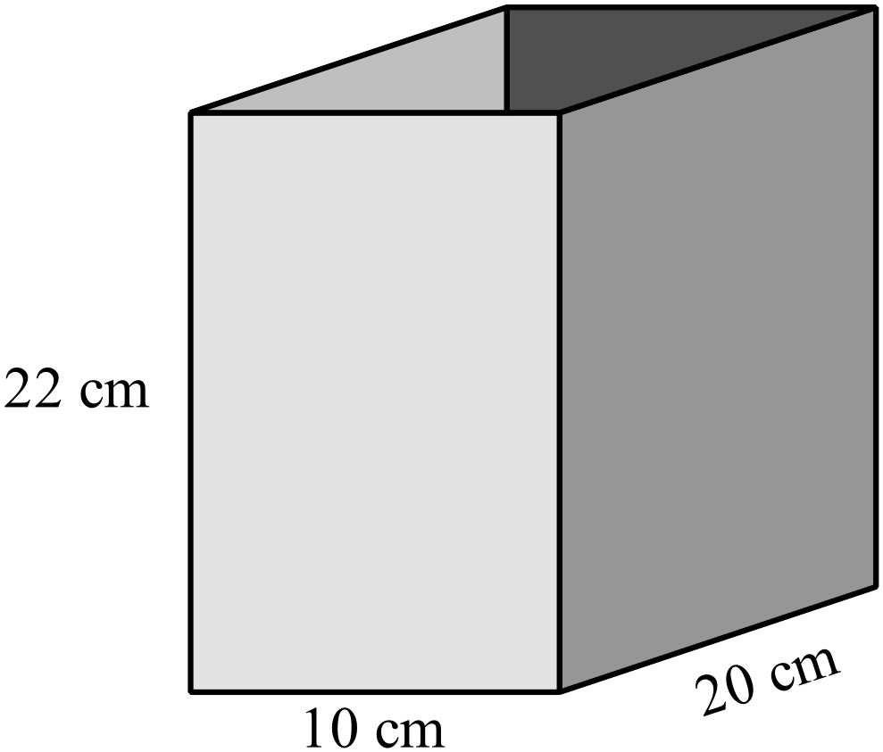The storage box shown is open at the top and made from cardboard.  What area of cardboard in used to make the box?  ……………………………………………………  ………...………………………………………....  ………...………………………………………....  ……………………………………………………
20. | A grain hopper is in the shape of a square pyramid as shown.  What volume could the hopper hold when full to the top?  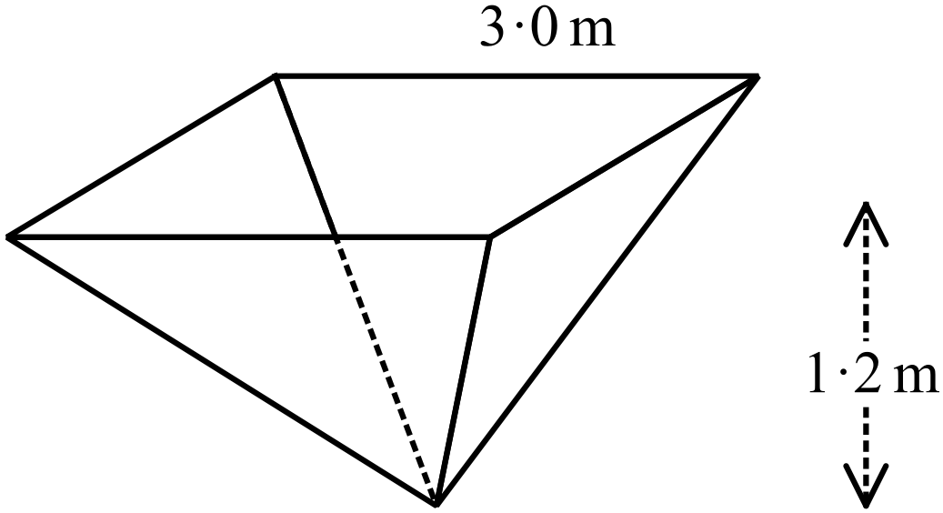  ……………………………………………………  ………...………………………………………....  ………...………………………………………....  ……………………………………………………
21. | Draw the image of the figure PQRS when it is reflected in the line AB.  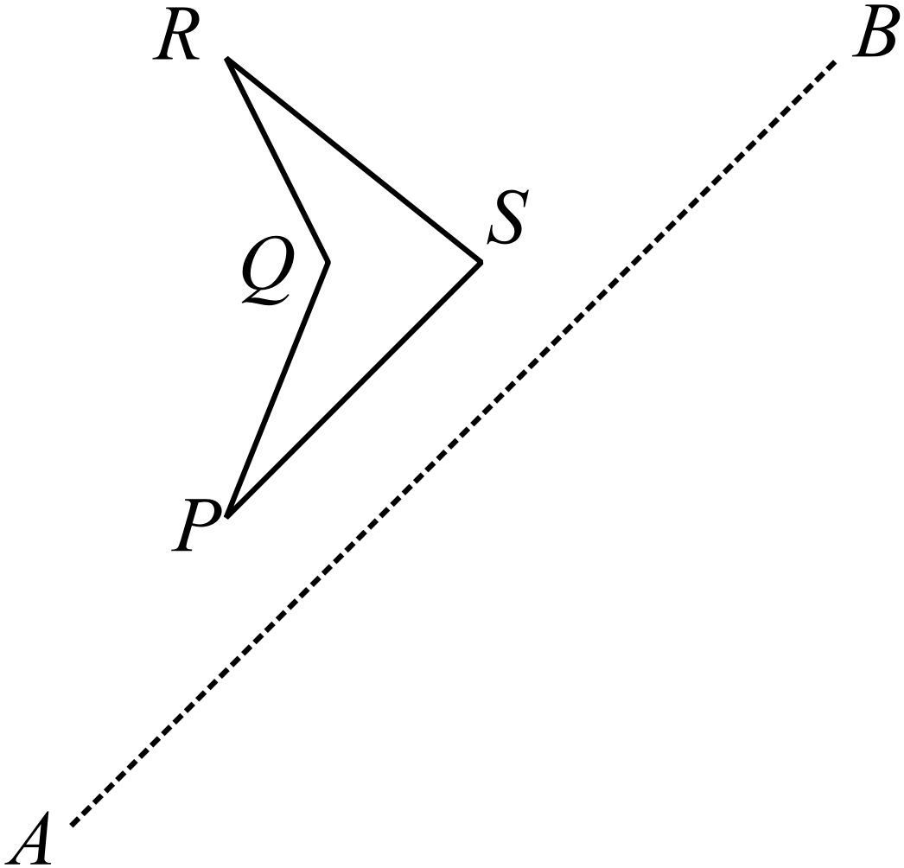
22. | 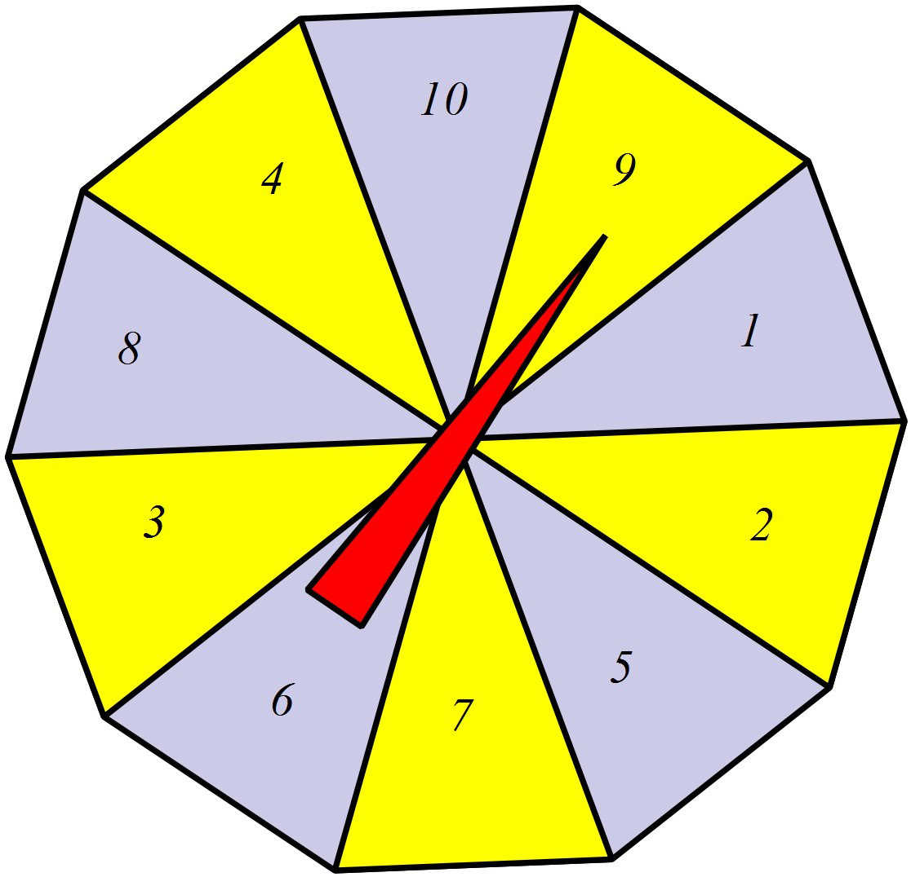A spinner has ten equal sectors numbered 1 to 10 as shown.  On a single spin, what is the probability that the spinner lands on a number which is divisible by 3?  ………………………………………………………………….  …………………………………………………………………
23. | 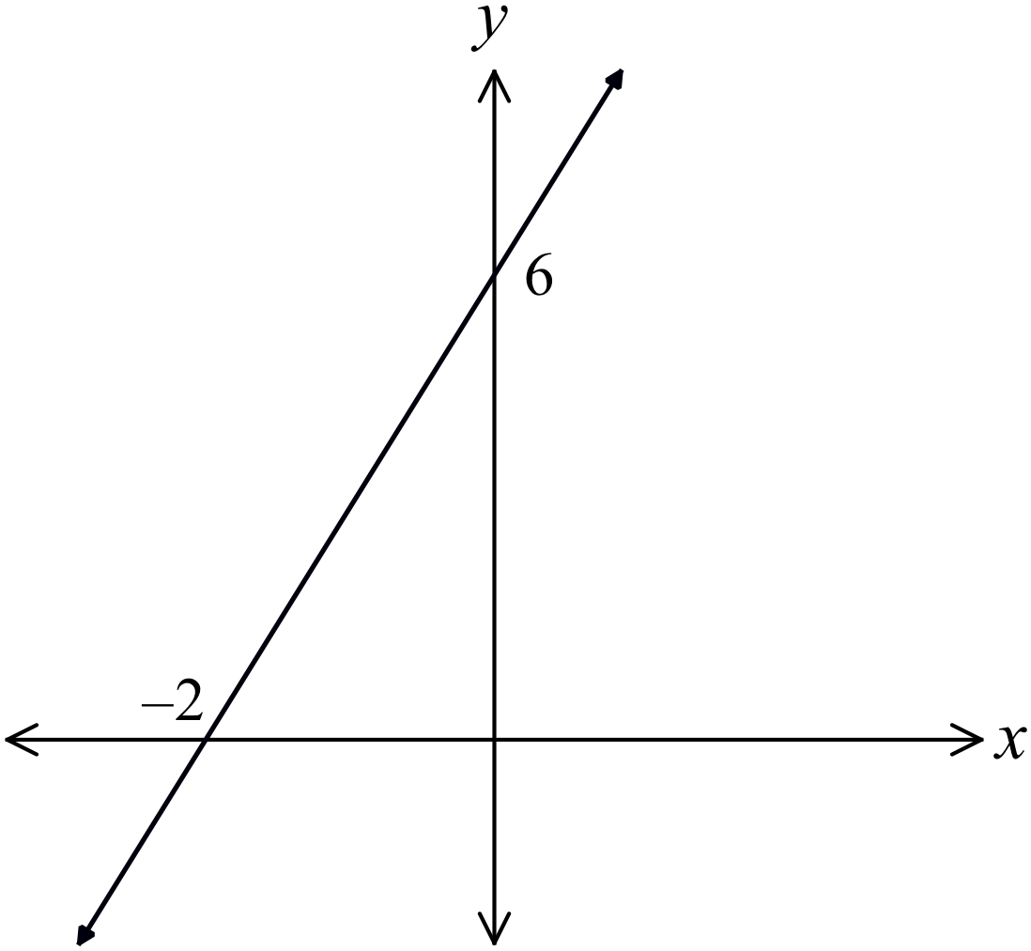Determine the equation of the line shown on the number plane.  ………………………………………………  ……………………………………………....  ………………………………………………  ……………………………………………….
24. | 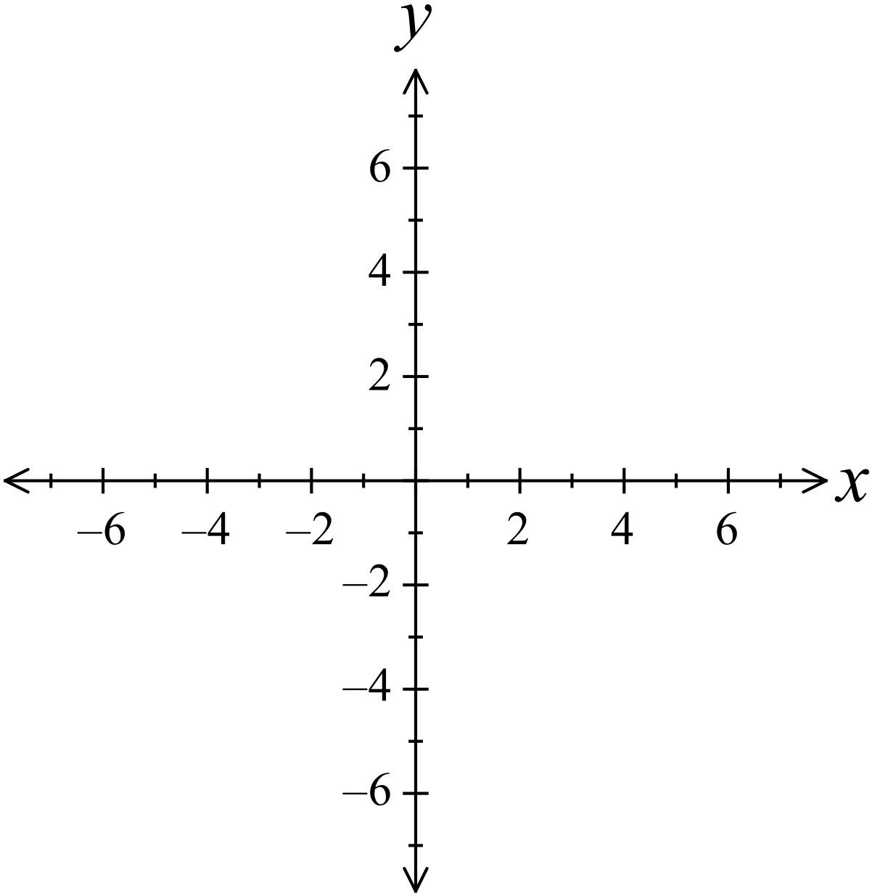Sketch the curve 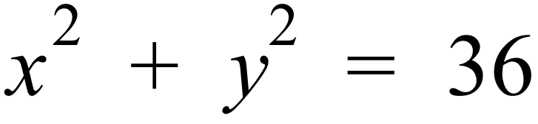 on this number plane.  ………………………………………………  ……………………………………………....  ………………………………………………  ……………………………………………….
25. | 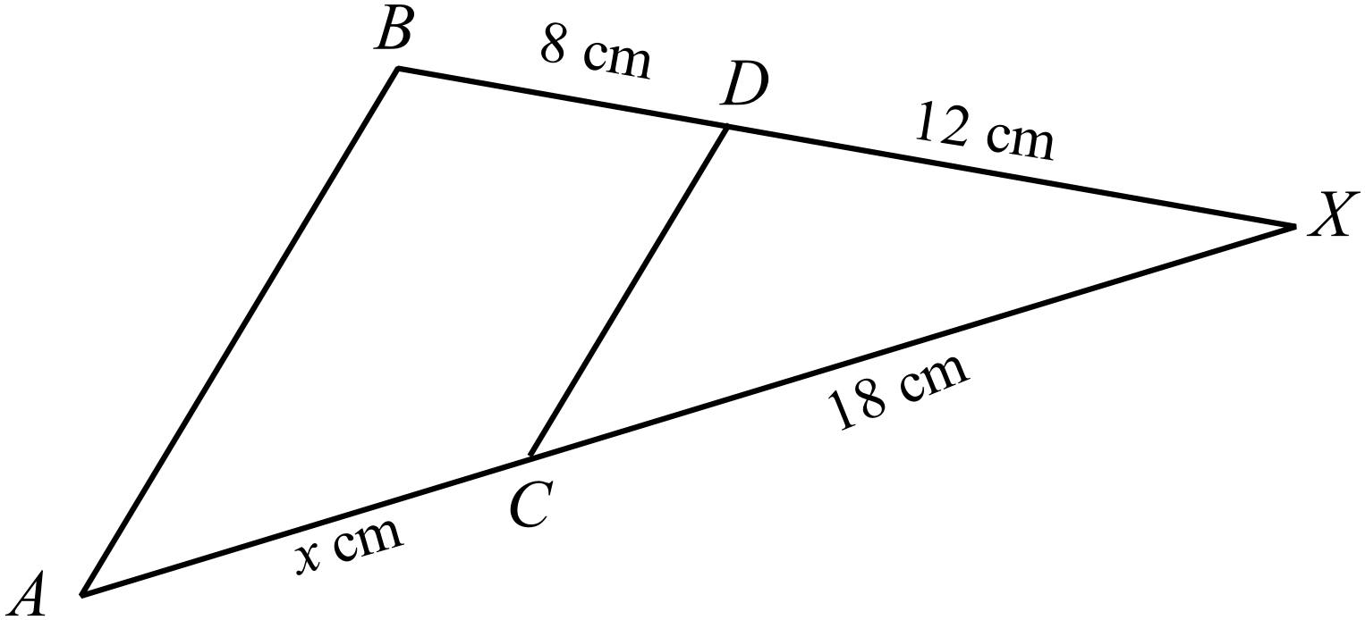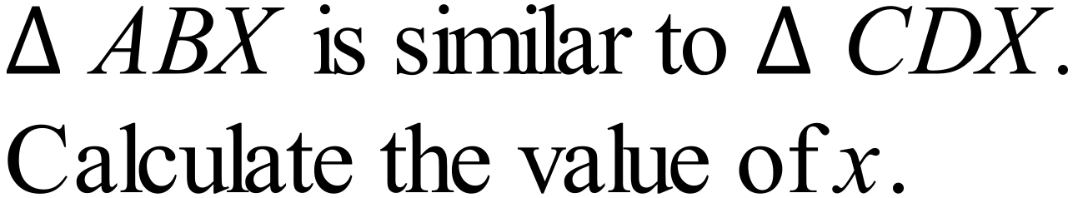  …………………………………………  …………………………………………  …………………………………………  …………………………………………

End of Section 1

Fallow Page

School Name
Yearly Examination
Mathematics Course
2016

Section 2

75 marks
Time allowed for this section is
1 hour and 30 minutes

This section has TWO parts

Part A – Fifty multiple-choice questions worth 1 mark each.
Mark your answers on the separate answer sheet provided at the end of the examination.
Part B – Longer answer questions worth a total of 25 marks.
Write all answers and working in the spaces provided on this examination paper.

Calculators may be used in this section.

Do not commence Section 2 until you are instructed to do so.

Section 2 - Part A
Use the multiple choice answer sheet at the end of the paper to record your answers.
Complete shade the bubble corresponding to the correct answer for each question.

Which fraction is equivalent to 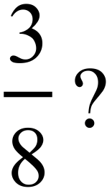
A. 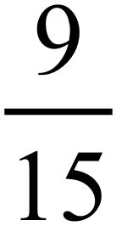 B. 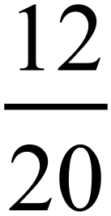 C. 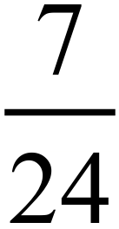 D. 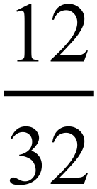
A jug holds of 2.4 litres of juice.
The entire contents of the jug are poured evenly into eight glasses.
How many litres are in each glass?
A. 0.03 litres B. 0.3 litres C. 0.6 litres D. 1.2 litres
Jeannie is paid an annual salary of $112 320.
She is paid weekly and has 30% of her salary deducted for taxation.
How much would she be paid each week?
A. $756 B. $1 512 C. $2 160 D. $4 320
A jewellery store bought a necklace for $160.00 and sold it for $264.00.
What percentage profit did the store make?
A. 35% B. 55% C. 65% D. 68%
A quadrilateral has the following properties:
- The diagonals bisect one another.
- The diagonals are unequal.
Which of these quadrilaterals would fit this description?
A. A kite
B. A parallelogram
C. A rectangle
D. A square
A volume of 1 cubic centimetre contains 1 millilitre of water.
How many litres of water would be contained inside a cube with sides 2 metres long?

A. 400 L B. 2 000 L C. 8 000 L D. 8 000 000 L
By measurement and calculation find the area of the triangle shown below.
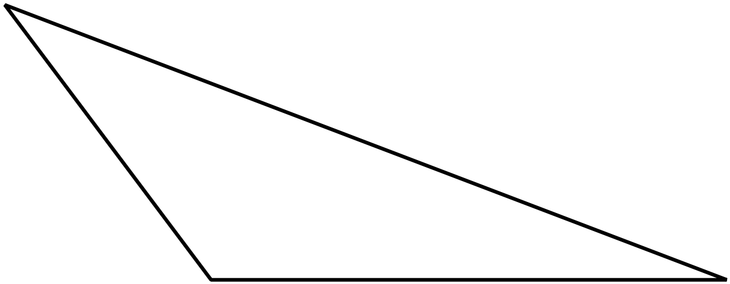

A. 11.25 cm²
B. 15 cm²
C. 18.75 cm²
D. 30 cm²
Simplify 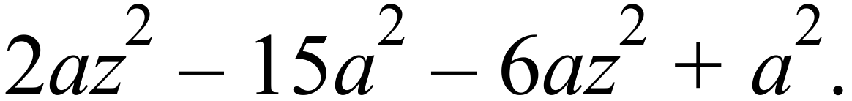

A. 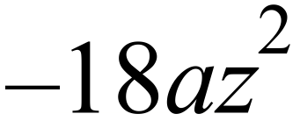
B. 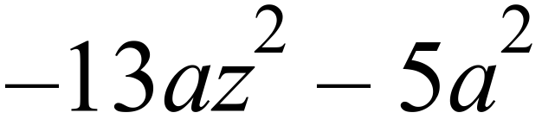
C. 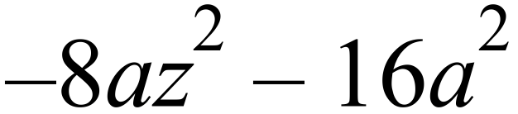
D. 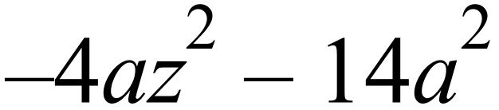
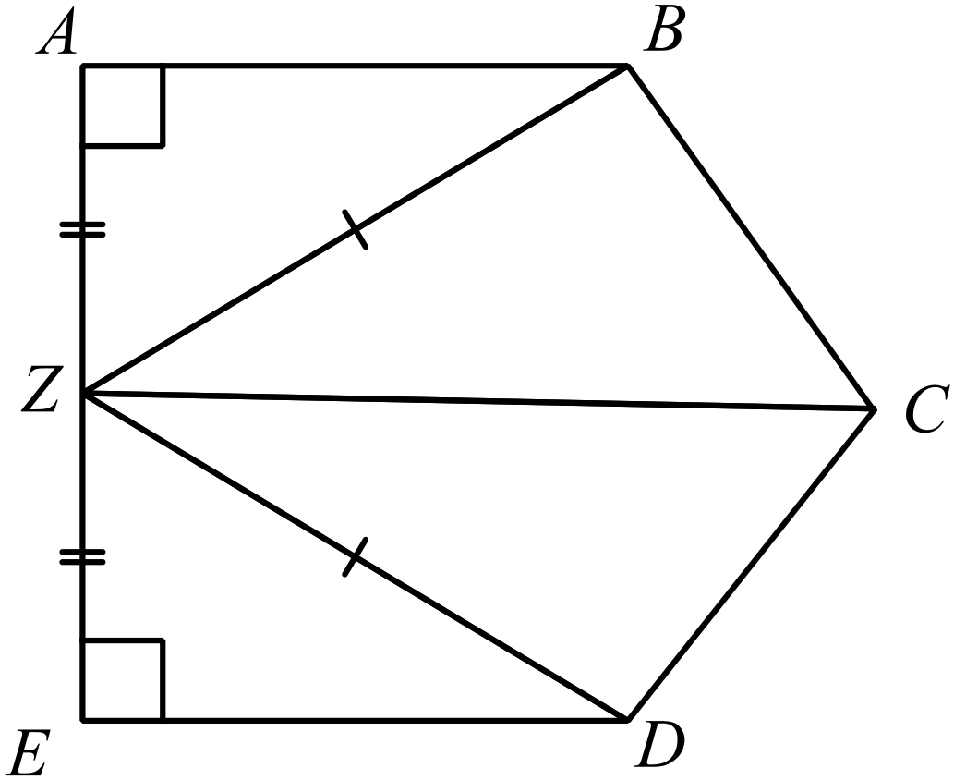Which pair of triangles are congruent?

A. 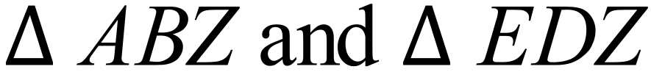
B. 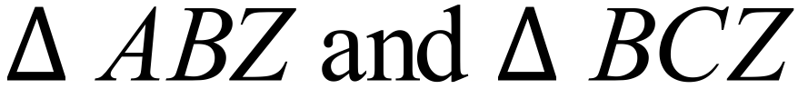
C. 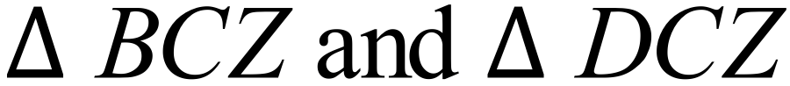
D.
Which of the following expressions is equal to 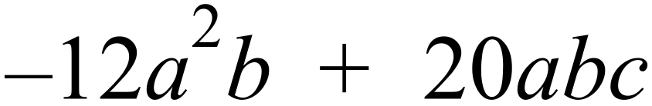 ?

A. 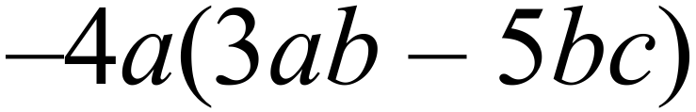
B. 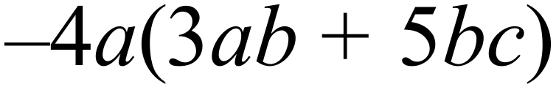
C. 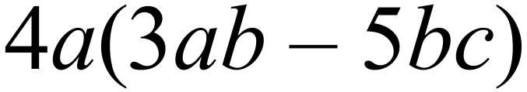
D. 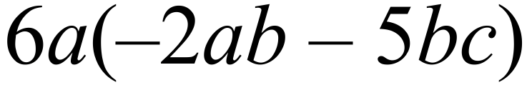
The graph shows the results of a survey of activities at Lake Wallace.
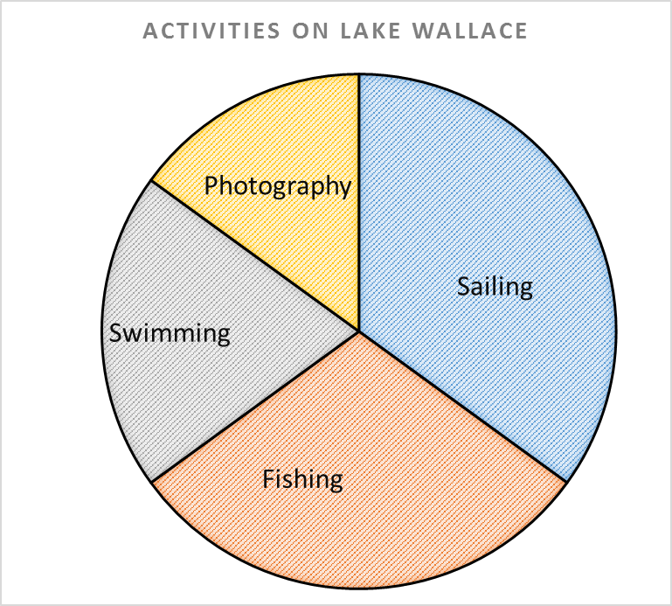

Which activity was chosen by 30% of those surveyed?
A. Fishing B. Photography C. Sailing D. Swimming
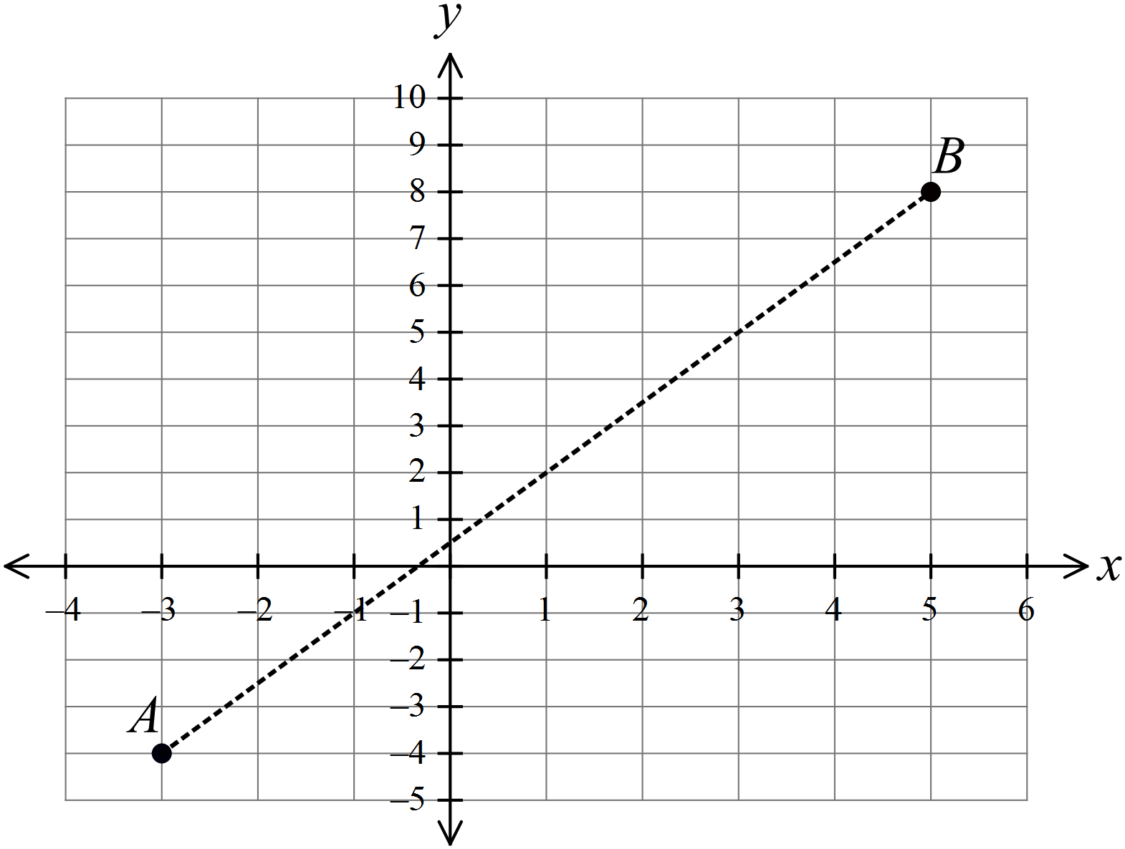Calculate the exact distance between the points A(–3, –4) and B(5, 8) on the number plane.

A. 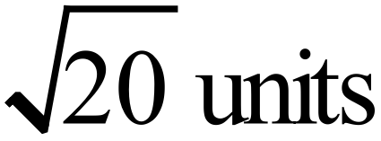
B. 
C. 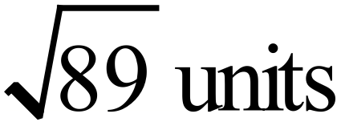
D. 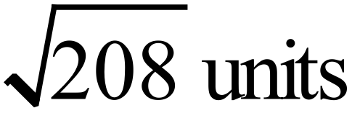

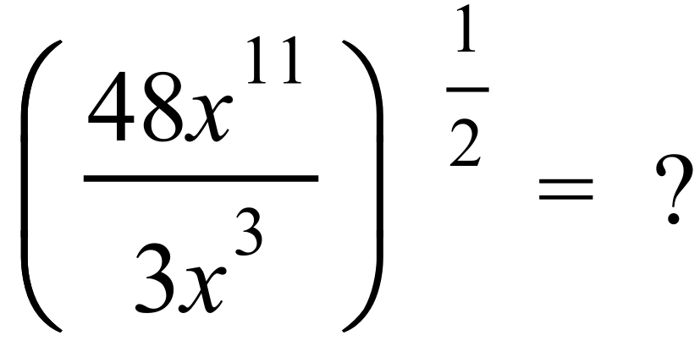
A. 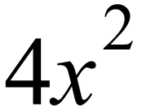 B. 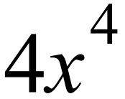 C. 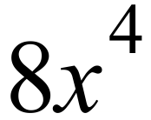 D. 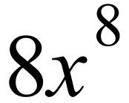
Solve the equation 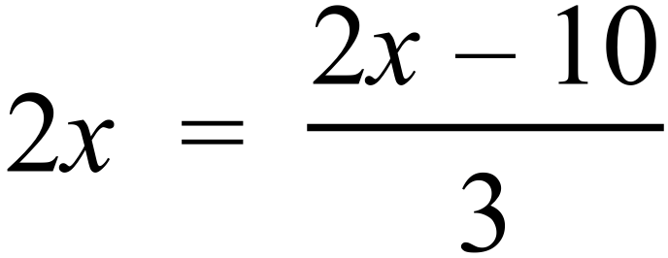 .

A. 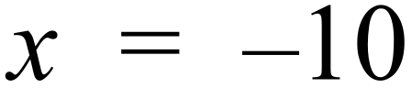 B. 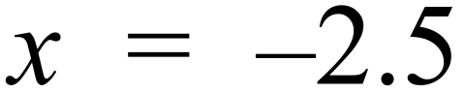 C. 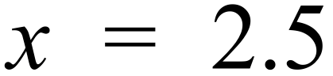 D. 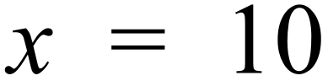
Which of these ratios simplifies to 5 : 9 ?
A. 3 : 4.5 B. 3 : 4.8 C. 3 : 5.4 D. 3 : 5.5
Questions 41 and 42 refer to the following.
The dot plot was constructed by counting the number of spots on individual Dalmatians at a show.
 | ⃝
⃝ | ⃝ | ⃝ | ⃝ |  | ⃝
⃝ | ⃝ | ⃝ | ⃝ | ⃝ | ⃝
⃝ | ⃝ | ⃝ | ⃝ | ⃝ | ⃝
⃝ | ⃝ | ⃝ | ⃝ | ⃝ | ⃝ | ⃝
25 | 26 | 27 | 28 | 29 | 30 | 31
Number of Spots

What fraction of the Dalmatians had less than 30 spots?

A. 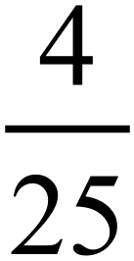 B. 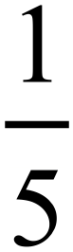 C. 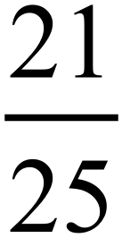 D. 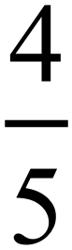
Which statement is correct?

A. The median number of spots was 26 and the lower quartile was 25.
B. The median number of spots was 26 and the lower quartile was 26.
C. The median number of spots was 27 and the lower quartile was 25.
D. The median number of spots was 27 and the lower quartile was 26.
What is the value of  in the right triangle below?
Answer correct to the nearest whole number.
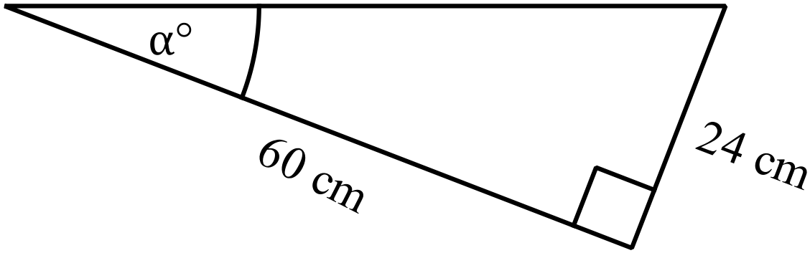 A. 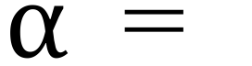 22
B. 24
C. 66
D. 68
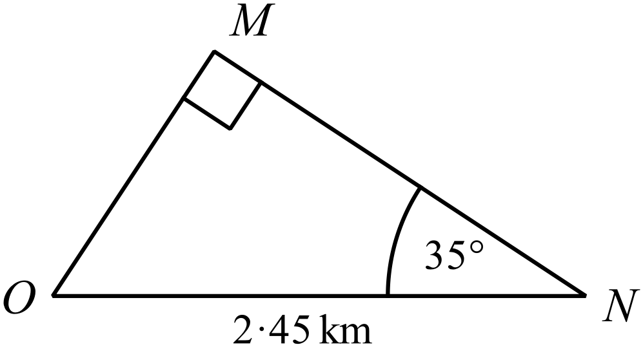What is the distance MN in the 
Answer correct to the 3 significant figures.
A. 1.41 km
B. 1.72 km
C. 2.01 km
D. 2.99 km
Justin invests $30 000 for a period of 4 years in an account which pays 6% p.a. interest compounding annually.
What is the amount in the account at the end of the 4 years?
A. $30 726.51
B. $31 800.00
C. $37 200.00
D. $37 874.31
The tube used inside a roll of aluminium foil is made of cardboard.
It has a diameter of 2.4 cm and is 30 cm long.
What area of cardboard is needed to make 2 500 of these tubes?
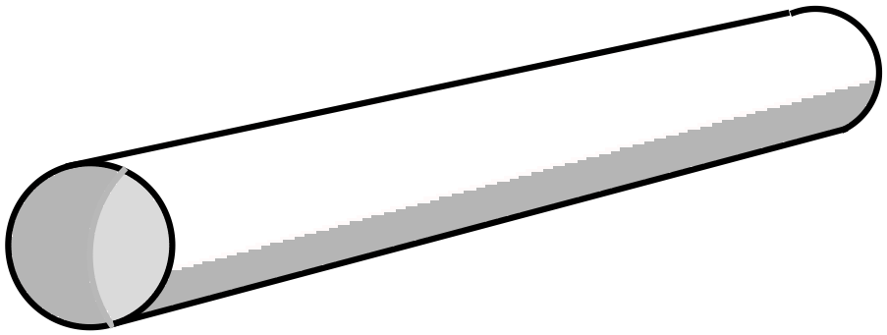(Answer correct to the nearest 1 000 cm²)
A. 283 000 cm²
B. 339 000 cm²
C. 565 000 cm²
D. 1 130 000 cm²
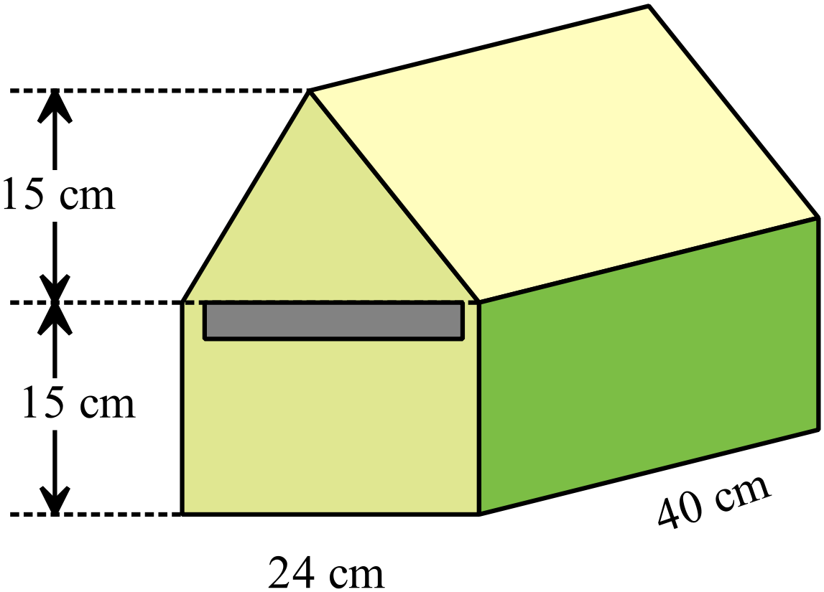A letterbox is a prism, made in the shape and sizes shown.
What is the volume of air contained inside the letterbox?

A. 7 200 cm³
B. 14 400 cm³
C. 21 600 cm³
D. 28 800 cm³

One letter is selected at random from those making up the word OPPORTUNITIES.
What is the probability that it is an O or a U?

A. 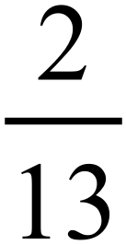 B. 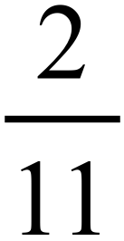 C. 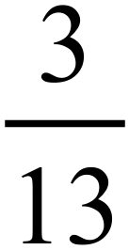 D. 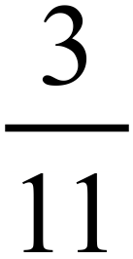
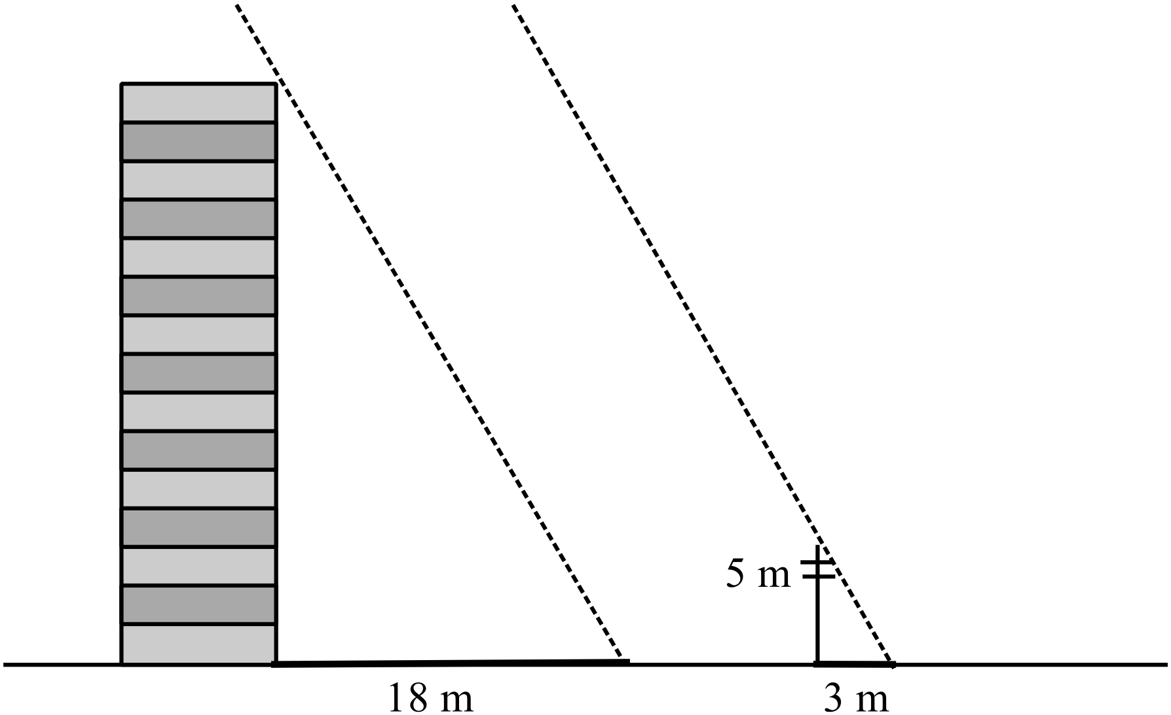A multi-storey block of units casts a shadow which is 18 m long.
At the same time a 5 m high power pole near the block casts a shadow which is 3 m long.
Calculate the height of the block of units.

A. 10.8 m
B. 15.0 m
C. 26.0 m
D. 30.0 m
Debbie left home at 5 a.m. and drove to an appointment, then returned at 4:30 p.m. on the same day.
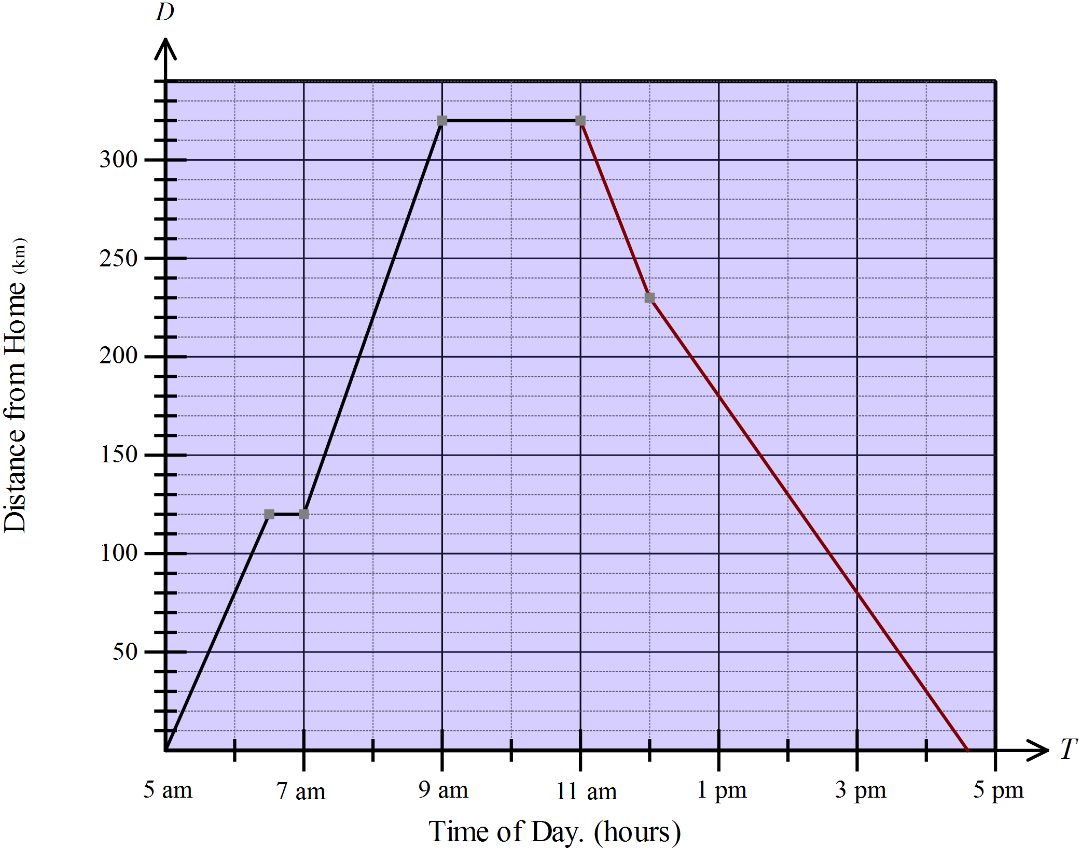

How many hours during the day did she spend driving?
A. 9 hours B. 9.5 hours C. 11 hours D. 11.5 hours
Which of the points represent the position of 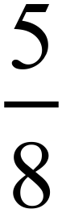 on the number line?

A. Point A B. Point B C. Point C D. Point D
Neil invests $6 400 in an account that pays 6% p.a. simple interest.
How long will he need to leave the money invested to earn $672 in interest?
A. 1 year and 8 months B. 1 year and 9 months
C. 1 year and 10 months D. 2 years
In the diagram below, CF and EG are straight lines and  is a right angle.
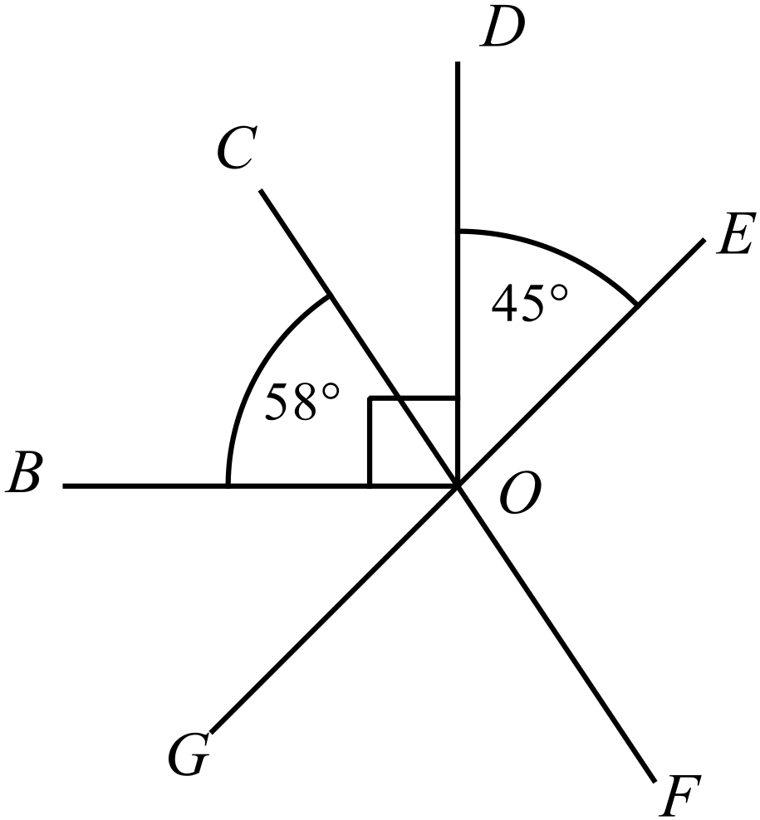Also
What is the size of 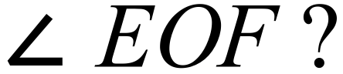

A. 103º
B. 122º
C. 135º
D. 148º
What is the value of in the diagram below?
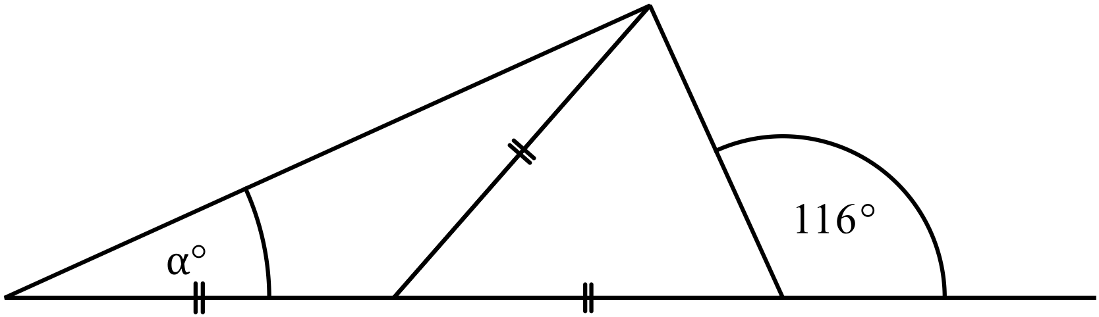

A. 16º B. 26º C. 32º D. 52º
Four years ago, Andrew purchased a printer for his business.
The purchase price was $36 000 and the depreciation rate over the time was 12% p.a.
What is the value of the printer now?
A. $18 720.00
B. $21 589.03
C. $21 902.40
D. $24 532.99
Expand and simplify 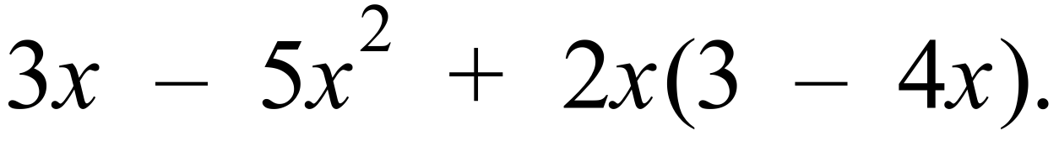

A. 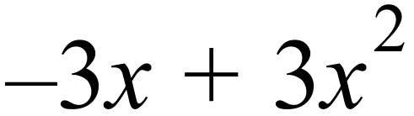
B. 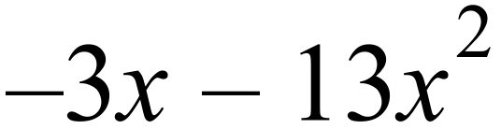
C. 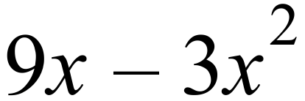
D. 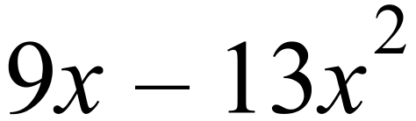
Which of these expressions is not a factor of 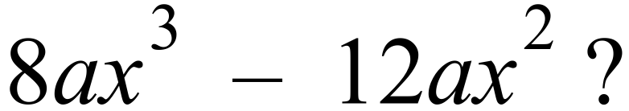

A. 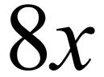 B. 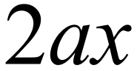 C. 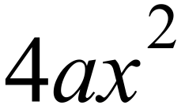 D. 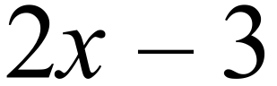
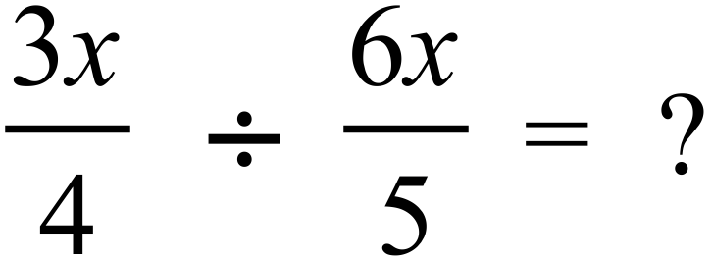

A. B. 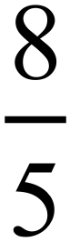 C. 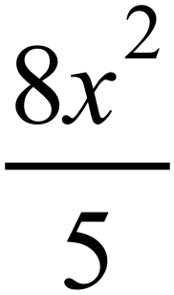 D. 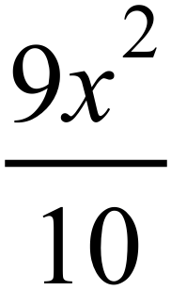
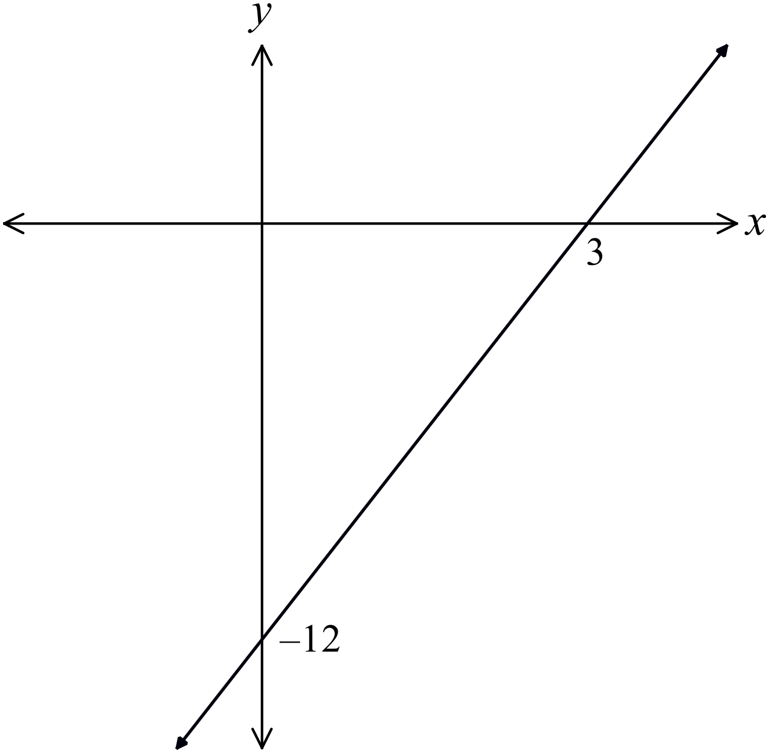What is the equation of the line shown on the number plane?

A. 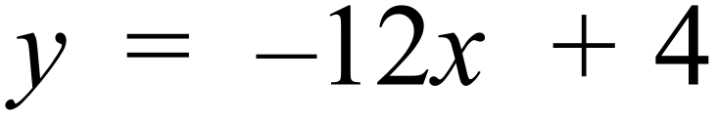
B. 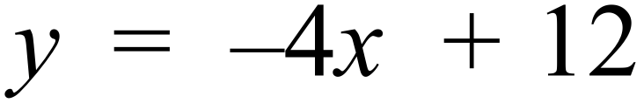
C. 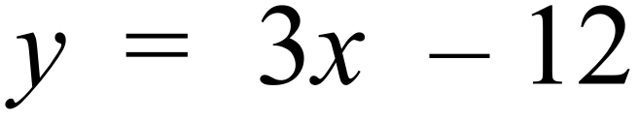
D. 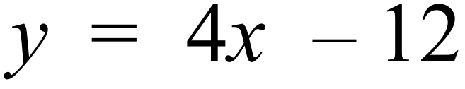

The mass of the Earth is estimated to be 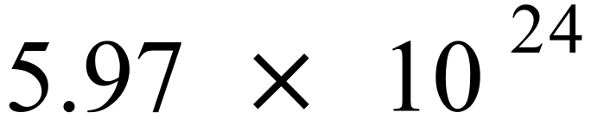 kg and that of Mars to be 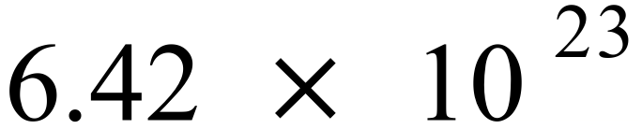 kg.
What percentage of the Earths mass is that of Mars?
(Answer correct to 3 significant figures)
A. 10.8% B. 108% C. 1 080% D. 10 800%
Which number line graph represents 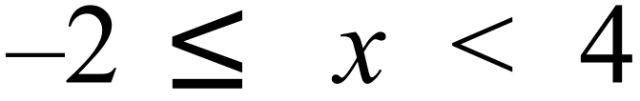 ?
A.
B.
C.
D.
Questions 62 and 63 refer to the following:
A television talent program gives contestants a total score out of 100.
The scores of 48 contestants are represented in the box and whisker plot below.
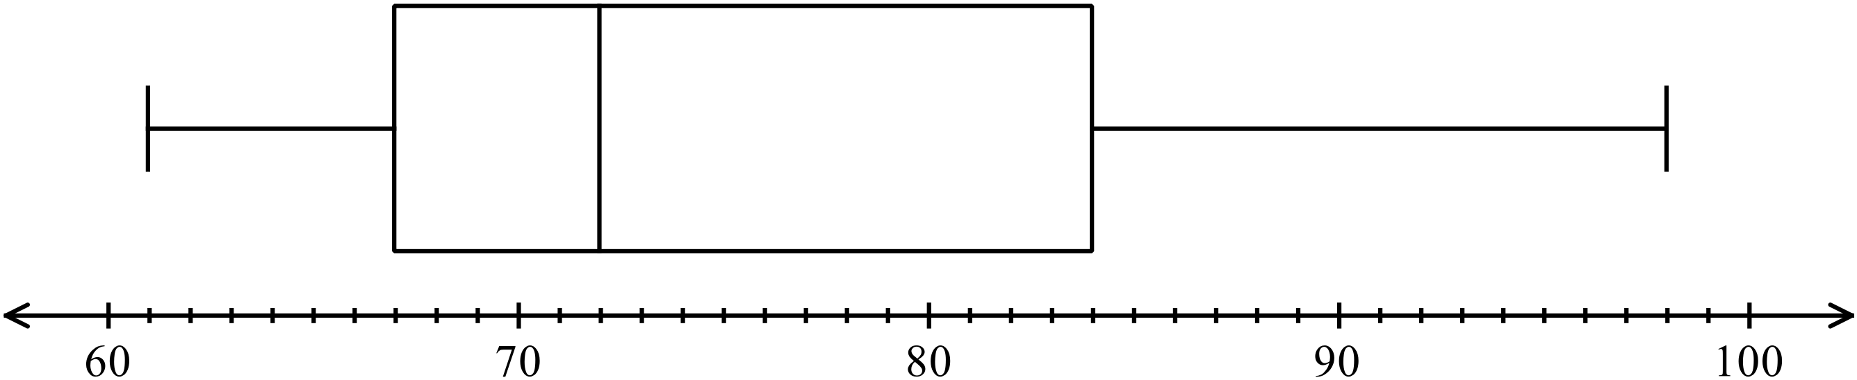

Based on the graph, which of these descriptions could be used to describe the shape of the distribution of scores?
A. The distribution of scores is bimodal in shape.
B. The distribution of scores is negatively skewed.
C. The distribution of scores is positively skewed.
D. The distribution of scores is symmetrical.
How many contestants had scores of 67 or more?
A. 12 B. 24 C. 31 D. 36
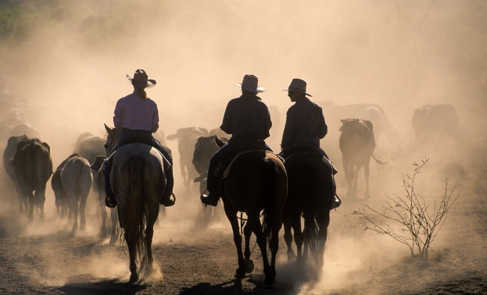
A group of drovers are taking a herd to fresh pasture.
The 250 cattle in the herd come from four stations.
The table shows the home station for the cattle.
Home Station | Number of Cattle
Aster Park | 80
Birch Downs | 65
Camelia Station | 42
Daffodil Estate | 63

If one of the cattle breaks free from the herd, what is the probability that it does not come from Birch Downs?
A. 0.26 B. 0.35 C. 0.74 D. 0.83
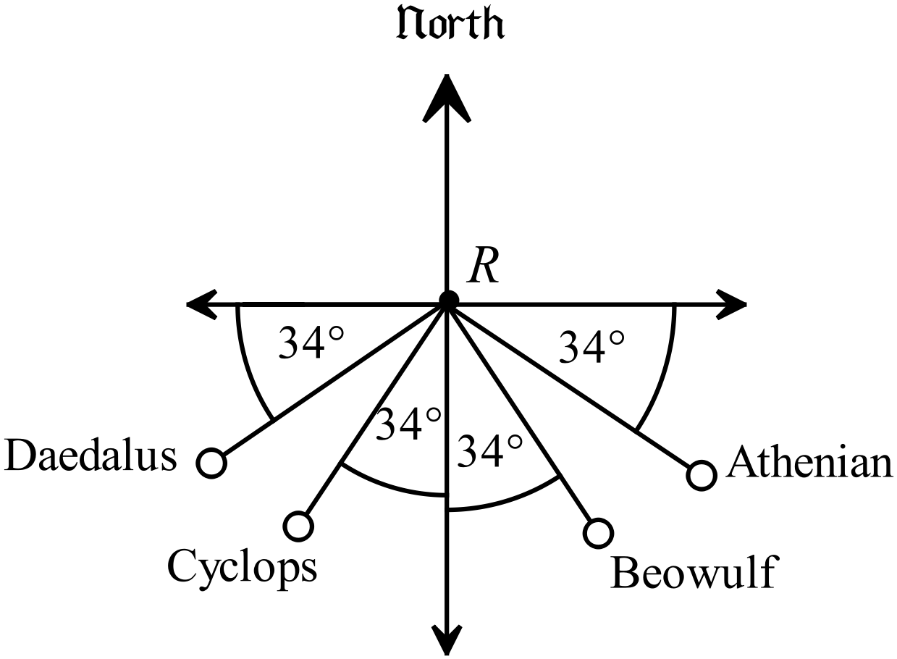Four boats are located by a radar station which is at the point R.
Their positions are shown on the diagram.
Which boat in on a bearing of 236º from R?

A. Athenian
B. Beowulf
C. Cyclops
D. Daedalus
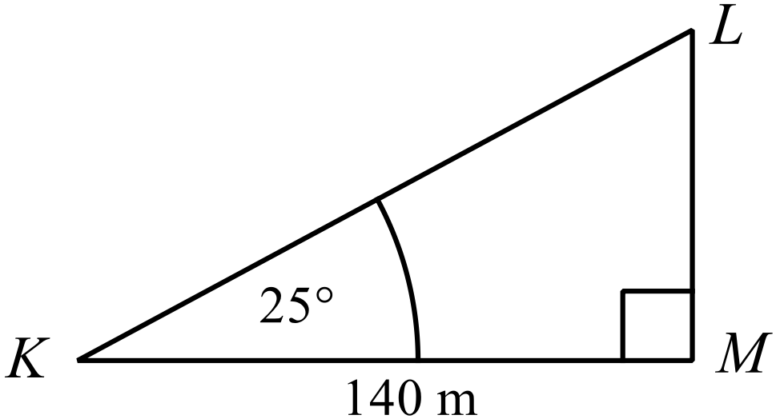In , KM = 140 m and 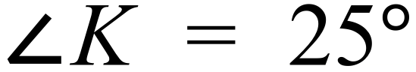.
What is the length of KL?
Answer to the nearest metre.
A. 154 m
B. 173 m
C. 300 m
D. 331 m
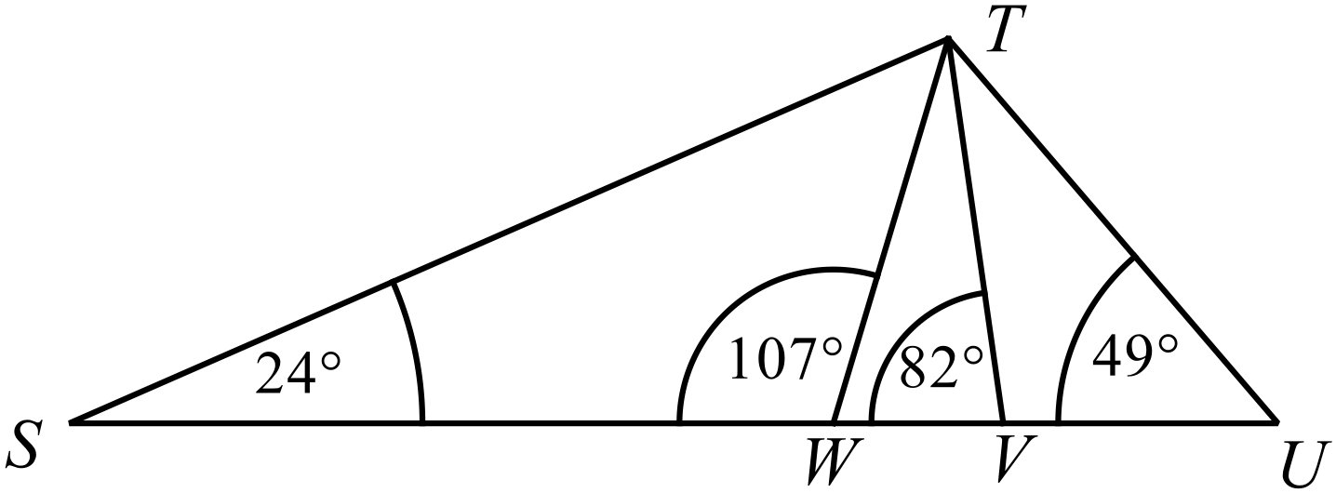Which triangle is similar to 
A. 
B. 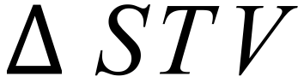
C. 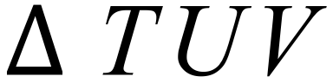
D. 
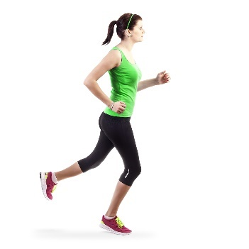
Louise runs 750 m in 3 minutes.
What is her speed in km/h?

A. 4.2 km/h
B. 7.5 km/h
C. 12 km/h
D. 15 km/h
Kristy borrows $30 000 and agrees to repay the principal and interest at the end of four years.
Interest is calculated at 7.2% p.a., compounded monthly.
How much must she repay?
A. $37 874.31
B. $38 640.00
C. $39 978.30
D. $42 332.67
Which of these lines would be parallel to the line 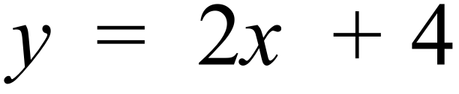 and pass through the point (2, –6).
A. 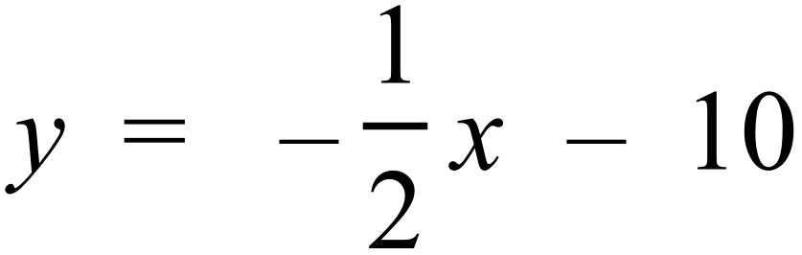
B. 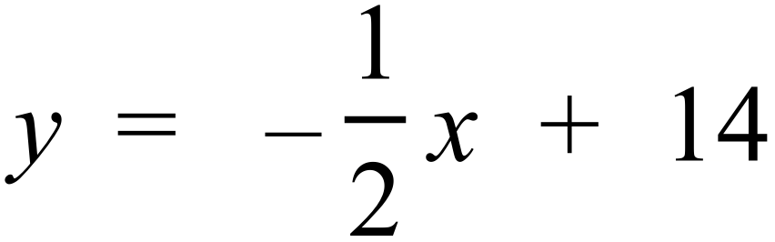
C. 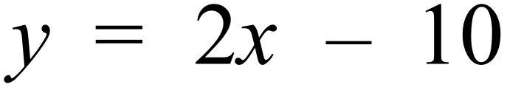
D. 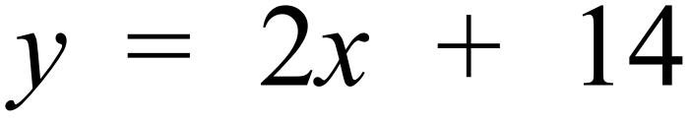
Which expression is equal to 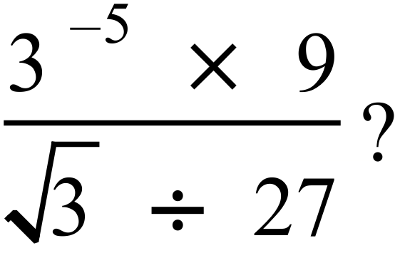
A. 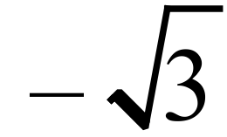 B. 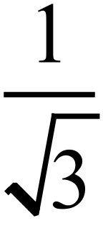 C. 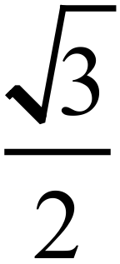 D. 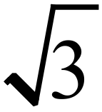
Questions 72 and 73 refer to the following:
The scatterplot compares the age of the entrant with the number of mistakes they made in an essay competition.
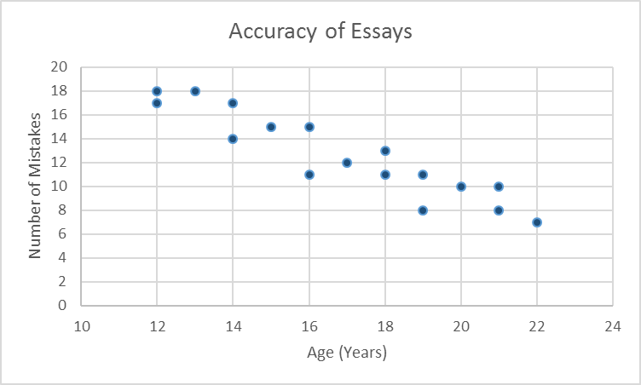

What was the mean number of mistakes for those aged 16 and under?

A. 14 B. 14.5 C. 15.4 D. 15.625
Which best describes the relationship shown on the scatter plot?
A. There is a strong negative relationship between age and number mistakes.
B. There is a weak negative relationship between age and number mistakes.
C. There is a strong positive relationship between age and number mistakes.
D. There is no relationship between age and number of mistakes.
Which equation could possibly describe the curve shown on the number plane?
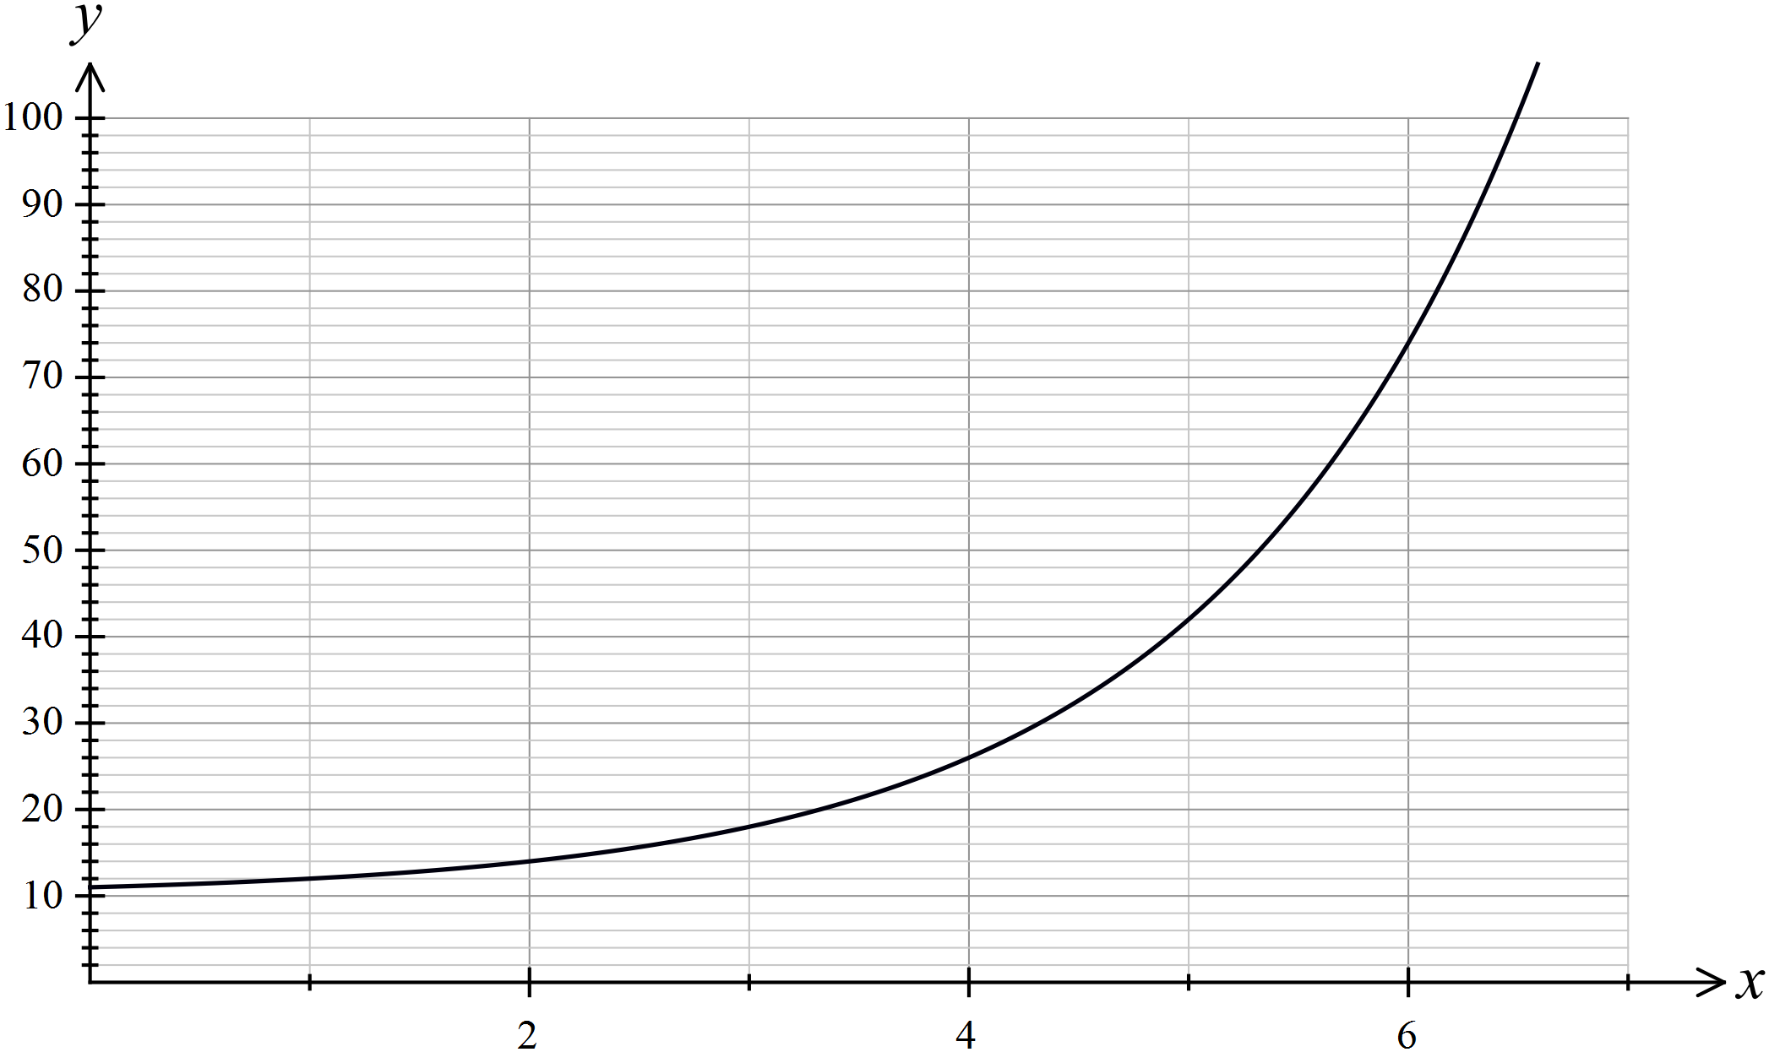

A. 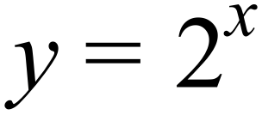
B. 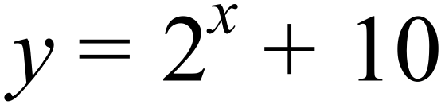
C. 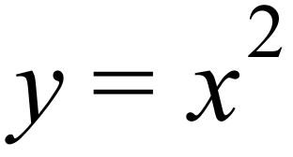
D. 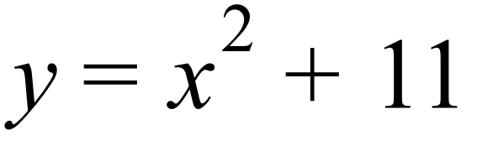
Which of the equations below would represent a parabola on the number plane?

A. 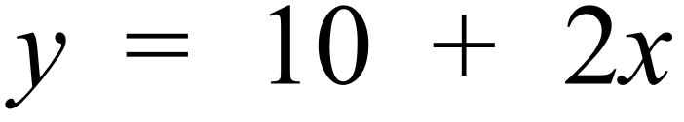
B. 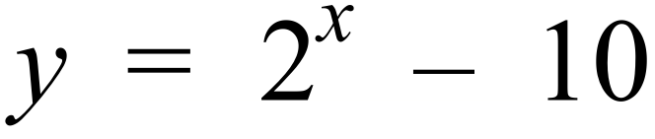
C. 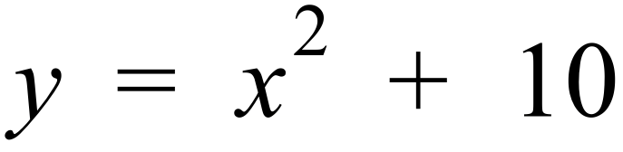
D. 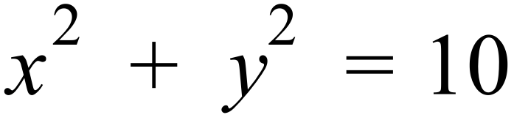
End of Section 2 - Part A

School Name  Yearly Examination |  | Mathematics Course  2016
Section 2  Part B  Longer Answer Section |  | Name : _______________________________
 |  | Class/Teacher___________________________
Write all working and answers in the spaces provided on this examination paper.
Calculators are allowed for this section.

 |  | Marks
76. | The stem and leaf plot shows the number of strokes taken by the competitors in a nine-hole golf competition.
  3 | 1 | 3 | 4 | 9 | 9
  4 | 0 | 1 | 5 | 5 | 8 | 8 | 9
  5 | 1 | 3 | 5 | 6 | 8
  6 | 2 | 4 | 6
  7 | 2
 | - How many competitors were there in the competition?  ……………………………………………………………………………………….. | 1
 | - What is the mean of the scores?  ………………………………………………………………………………………..  ………………………………………………………………………………………..  ……………………………………………………………………………………….. | 1
 | - Find the median score.  ………………………………………………………………………………………..  ……………………………………………………………………………………….. | 1
 | - What is the interquartile range?  ………………………………………………………………………………………..  ………………………………………………………………………………………..  ……………………………………………………………………………………….. | 1
77. | The triangular prism shown has an isosceles triangle as its cross section.  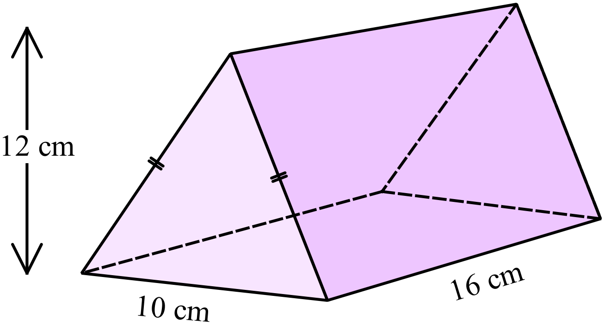
 | - Calculate the volume of the prism.  ………………………………………………………………………………………..  ………………………………………………………………………………………..  ……………………………………………………………………………………….. | 1
 | - Calculate the surface area of the prism.  ………………………………………………………………………………………..  ………………………………………………………………………………………..  ………………………………………………………………………………………..  ……………………………………………………………………………………….. | 2

78. | - Solve 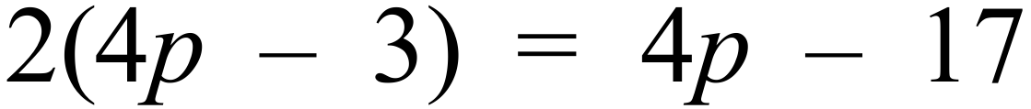 .  ………………………………………………………………………………………..  ………………………………………………………………………………………..  ………………………………………………………………………………………..  ……………………………………………………………………………………….. | 2
 | - Solve 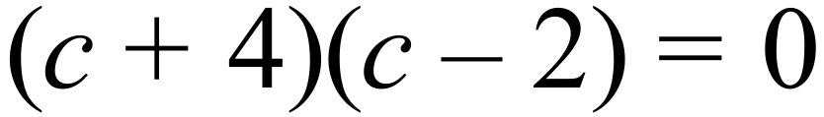  ………………………………………………………………………………………..  ……………………………………………………………………………………….. | 1
 | - Solve simultaneously 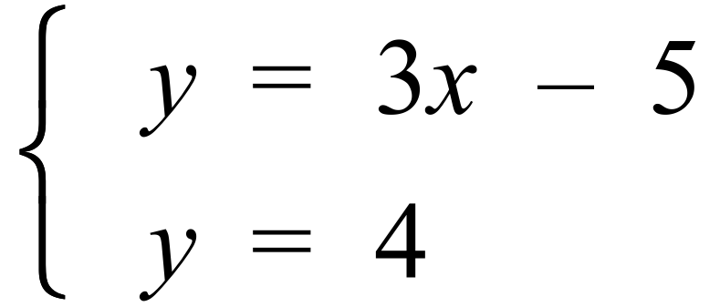  ………………………………………………………………………………………..  ………………………………………………………………………………………..  ………………………………………………………………………………………..  ……………………………………………………………………………………….. | 1
79. | Exactly three years ago, David invested an amount of money into an account which paid 8% p.a. interest, compounded quarterly.  He made no other deposits or withdrawals and today there is $59 100 in the account.  What was the principal (to the nearest dollar) that he invested three years ago?  ………………………………………………………………………………………..  ………………………………………………………………………………………..  ………………………………………………………………………………………..  ………………………………………………………………………………………..  ………………………………………………………………………………………..  ……………………………………………………………………………………….. | 2
80. | In the diagram below ABCD is a rectangle.  E and F are points on AB and DC such that DE = DF.  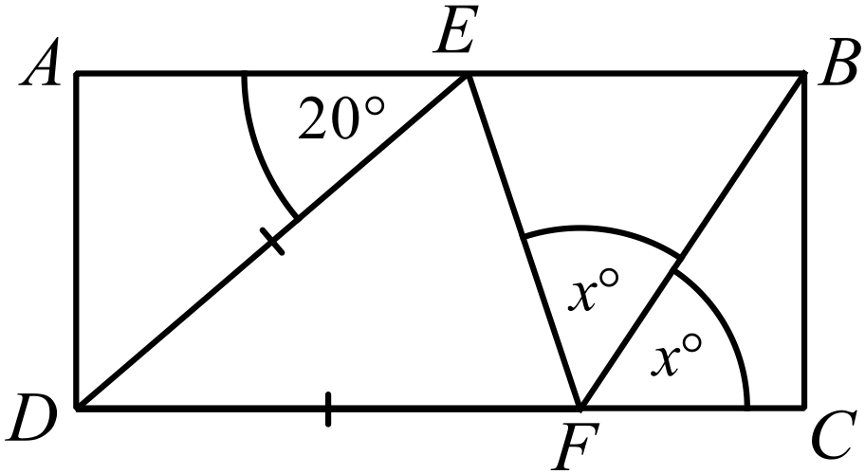  Find the value of x.  Give geometric reasoning for each step of your working.  ………………………………………………………………………………………..  ………………………………………………………………………………………..  ………………………………………………………………………………………..  ………………………………………………………………………………………..  ………………………………………………………………………………………..  ……………………………………………………………………………………….. | 2

81. | A hot air balloon A is 101 m directly above point D.  From point C which is due west of D, the angle of elevation of A is 40º.  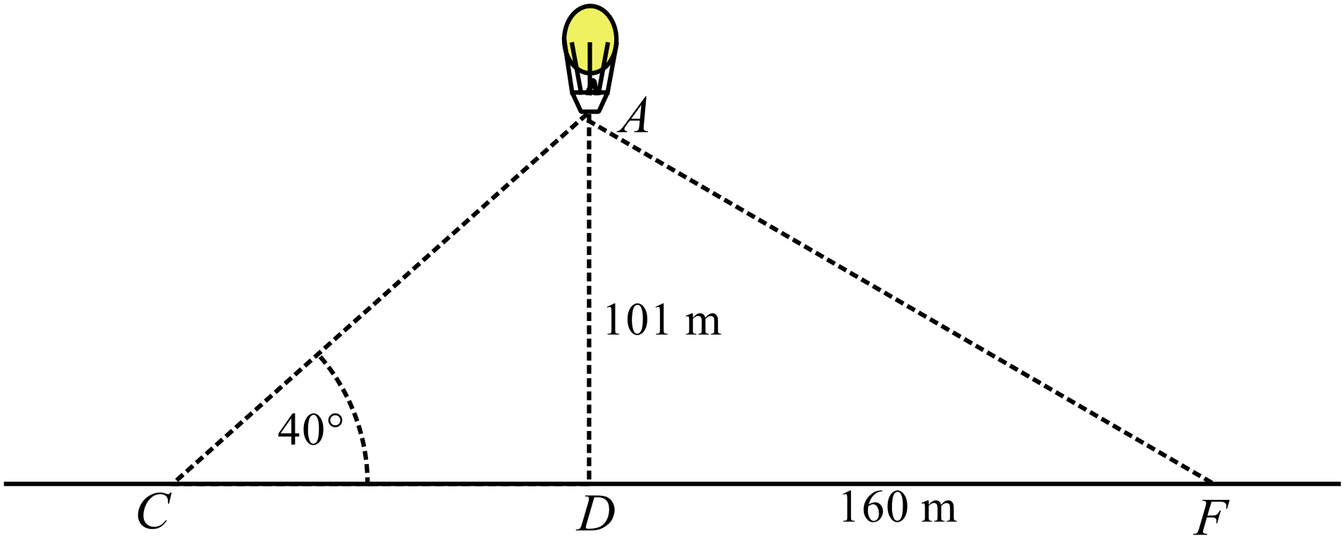
 | - Calculate the distance (to the nearest metre) from C to D.  ………………………………………………………………………………………..  ………………………………………………………………………………………..  ……………………………………………………………………………………….. | 1
 | - Point F is 160 m due east of D.  What is the angle of elevation (to the nearest degree) of balloon A from F?  ………………………………………………………………………………………..  ………………………………………………………………………………………..  ……………………………………………………………………………………….. | 1
 | - A second balloon B is higher than A and 200 m away in a straight line.  The angle of depression of A from B is 25º.  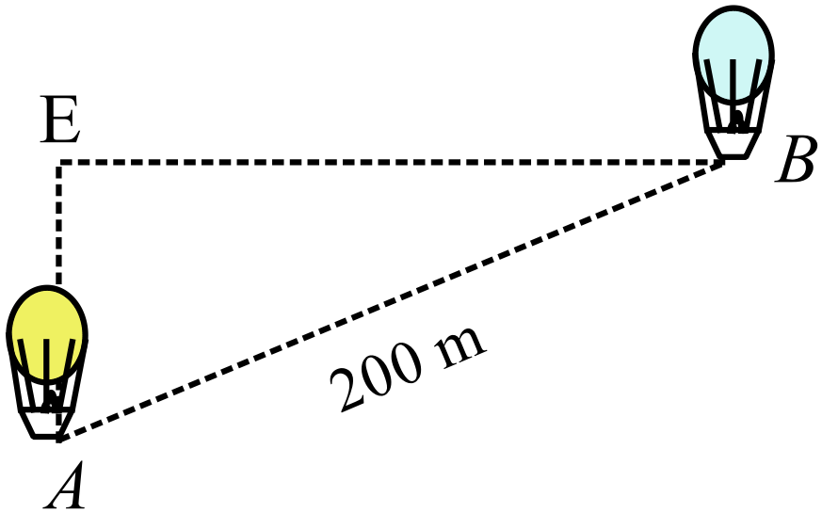  Calculate the distance of B above ground level (to the nearest metre).  ………………………………………………………………………………………..  ………………………………………………………………………………………..  ………………………………………………………………………………………..  ……………………………………………………………………………………….. | 2
82. | The curve 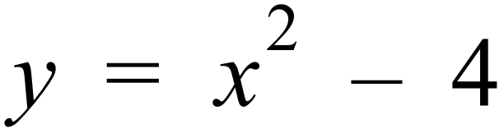 and a straight line labelled k have been drawn on the number plane below.  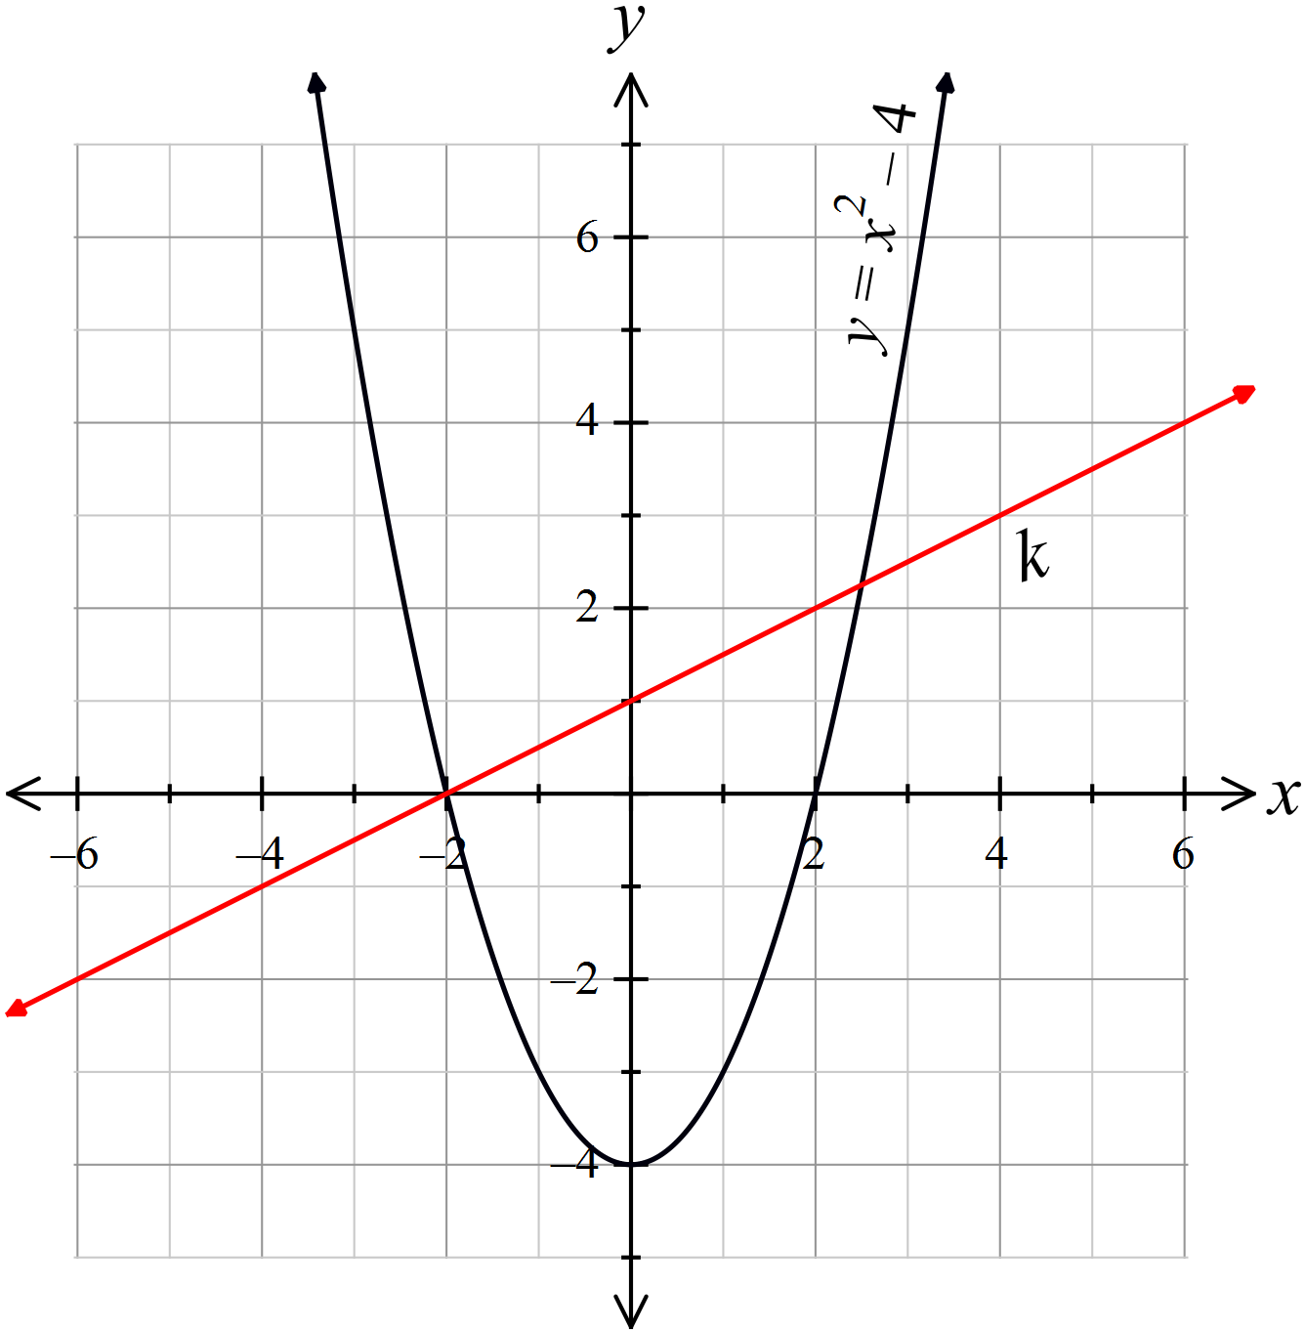
 | - Give the coordinates of the x intercepts of the curve  ……………………………………………………………………………………….. | 1
 | - Determine the gradient of the line k.  ………………………………………………………………………………………..  ………………………………………………………………………………………..  ……………………………………………………………………………………….. | 1
 | - On the number plane, draw the line which is perpendicular to k and passes through the origin.  Write down the equation of this line.  ………………………………………………………………………………………..  ………………………………………………………………………………………..  ……………………………………………………………………………………….. | 2
83. | 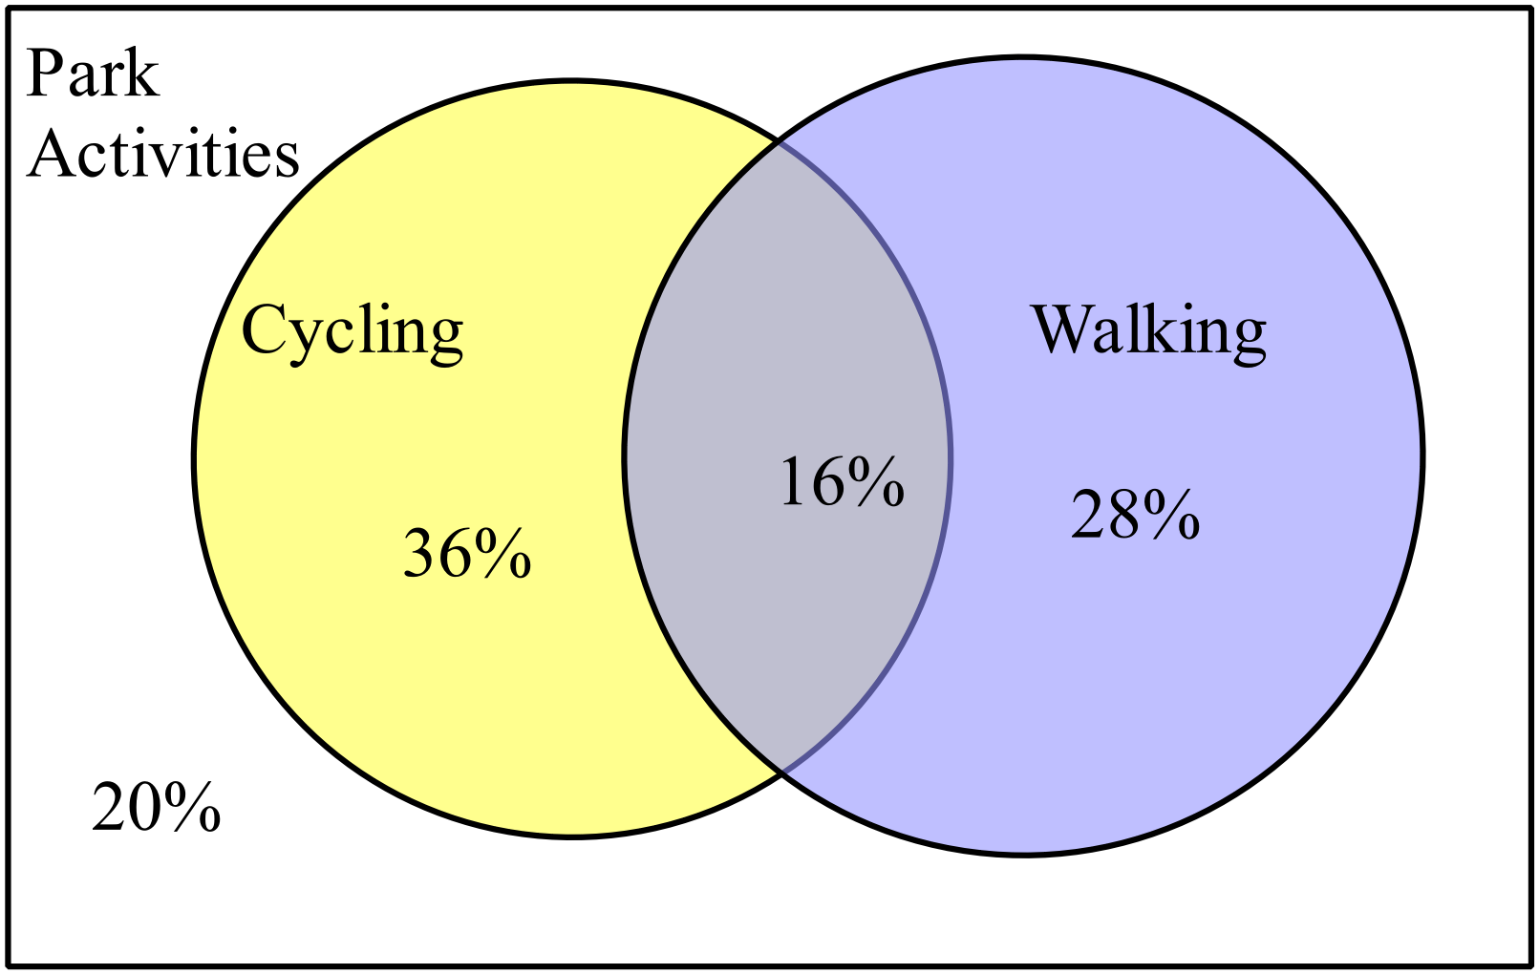The Venn diagram illustrates the results of a survey on the number of people who participated in activities in a local park.  A person is chosen at random from the survey group.
 | - What is the probability that the person participated in walking?  ………………………………………………………………………………………..  ……………………………………………………………………………………….. | 1
 | - What is the probability that the person did not participate in both walking and cycling?  ………………………………………………………………………………………..  ………………………………………………………………………………………..  ……………………………………………………………………………………….. | 1
 | End of Examination

Fallow Page

School Name
Year 10 Yearly Examination
Mathematics Course 2016
Multiple Choice Section Answer Sheet

Name ________________________________ Teacher ________________________

Completely fill the response oval representing the most correct answer.
Use a black or blue pen or 2B pencil.

26. A B C D
27. A B C D
28. A B C D
29. A B C D
30. A B C D
31. A B C D
32. A B C D
33. A B C D
34. A B C D
35. A B C D
36. A B C D
37. A B C D
38. A B C D
39. A B C D
40. A B C D
41. A B C D
42. A B C D
43. A B C D
44. A B C D
45. A B C D
46. A B C D
47. A B C D
48. A B C D
49. A B C D
50. A B C D

51. A B C D
52. A B C D
53. A B C D
54. A B C D
55. A B C D
56. A B C D
57. A B C D
58. A B C D
59. A B C D
60. A B C D
61. A B C D
62. A B C D
63. A B C D
64. A B C D
65. A B C D
66. A B C D
67. A B C D
68. A B C D
69. A B C D
70. A B C D
71. A B C D
72. A B C D
73. A B C D
74. A B C D
75. A B C D

